**Chapter I**

**INTRODUCTION**

Facility is a place or space provided for a particular purpose. It can not only be found in a business establishment but also in some infrastructure including the schools.

As we have experienced the conflict in using a facility in our school, we have decided to create a system that can be used to place a reservation on a particular space in the campus to avoid any collision on who will use the facility.

This project aims to aid the school community in efficiently managing the use of campus facilities. By implementing a reservation system, students, teachers and staff members can easily book the space they need for various activities like meetings or other events. This will help prevent double bookings and ensure that everyone has fair access to the facilities.

**BACKGROUND OF THE STUDY**

Reservation is a term used to keep something for someone in advance. Also, it is a process of booking and blocking rooms in advance for the prospective guests . This term is commonly used in accommodation units such as hotel, restaurant, room, facilities, etc.

In the previous month, we encountered a problem regarding the use of the university’s facility. There was a conflict on who will be using the said area in a particular time and date. In order to prevent this incident again, our project will be useful for the university to have full control over the campus spaces.

UI Facilities Reservation is a website that will help the recipients to reserve the chosen facilities in a specific time and date. They can also view the date and time of the following reservations for every area in order for them to see the availability of the facility.

**PURPOSE AND DESCRIPTION OF THE PROJECT**

The purpose of our proposed system is to assist them in improving their present event reservation procedure. In that instance, our proposed approach will benefit both the client and the UI employees. The time spent reserving and planning an event will not be excessive. Many systems now use a computerized procedure since it is more efficient and accurate. The introduction of modern technologies made it possible for humans to engage with one another in a simple and hassle-free manner. Whether in business, science, or whatever work a person undertakes, the quality and speed with which it is completed are improved with automation at its core. Upon implementing this newly proposed system, it will surely help them make the transactions more efficient than the old process they used to use. We believe that this project will be a great help to UI Facilities Reservation and their future clients in terms of reservations management.

**STATEMENT OF THE PROBLEM**

A description of the issue

For reservations and inquiries, the PHINMA UI Reservation system is manually operated. It is inconvenient, costly, and time-consuming for someone to physically visit the PHINMA UI Reservation System in order to make a reservation.

Reservation and inquiry. On account of this, the researcher has developed online software.

PHINMA UI is a reservation system that offers online booking and inquiry capabilities. So, saving Customer time to check into the PHINMA UI Reservation System.

**GENERAL OBJECTIVES**

The main objective of this study is to provide UI Facilities Reservation with a system that allows the preparation of Management and Reservation for the staff and users.

Objectives of the study:

* To create a system that only admin can give permission to a user to access the system.
* To create a system that will manage reservations for events such as meetings and events.
* To filter the records of reserved events covered by the entered date.
* To design a system that has a user-friendly interface for the user for an easy reservation process.
* To create backup records.
* To secure the information they gathered from the customers.
* To organize information about scheduled events.
* To provide a computer-based system that avoids conflicts in reservation of schedule.

**SPECIFIC OBJECTIVES:**

-The UI Facilities reservation engine is a type of digital solution with all the information that they may look for.

-online reservation systems reduce workloads and optimize customer service.

The following are the specific objectives:

* Generate and print out the complete report
* View the availability of the room in real-time.
* Effectiveness of the system
* Efficiency of the system
* Quality of the system
* Timeliness of the system

**PROJECT SCOPE**

- A computerized reservation whose main aim is to simplify and improve the life of Teachers Students or other clients that they would no longer be bound to the traditional method of seeking office space availability and other types of details are necessary for their preferences.

**LIMITATION OF THE PROJECT:**

- the system requires internet connection

- the system targets the customers to have their own phone, email or other social media platforms in order to receive some notification or verification that has to be sent by a team.

**SIGNIFICANCE OF THE STUDY:**

This study is significant to facilities/Students that they will no longer be by just looking for vacancies for an venue’s and making a reservation.

An Electronic reservation has already provided every citizen seeking with all the information that they may look for- including AVR, Auditorium, venue types, add-ons, inclusions, and other details.

This study will save seekers time because they will not need to wait for hours until the team confirms their reservation.

In addition, this study will also benefit the future researchers to contribute based on the unexpected gaps of this project and also provide a basis for their studies.

**Chapter II**

**REVIEW OF RELATED LITERATURE AND STUDIES**

Review of related literature and studies are the published works of the recent researchers which were related to our proposed study.

**RELATED LITERATURE AND STUDIES**

*Developing and Implementing Web-based Online University Facilities Reservation System*

The IAU facilities reservation online system has been designed and developed in this work. The proposed system solved the imbalanced use of the university facilities such as Halls, Theaters, Swimming pools and Stadiums, where the IAU reservation facilities system proposed to be used by the community as a part of the role of the university in the community services without any financial profit to the university. The proposed IAU facilities reservation system was designed and implemented using the Unified Modeling Language (UML), MySQL and visual basic (VB) programming language. The proposed system successfully solves the current lack of IAU facilities management and gives the ability for the community to reserve the university facilities without any financial profit. The proposed system can be also extended to other facilities of IAU or other universities or companies; this will improve the use of their facilities and resources.

*’A--VENUE’: ONLINE VENUE RESERVATION SYSTEM FOR RECOGNIZED STUDENT ORGANIZATIONS OF ADAMSON UNIVERSITY*

Adamson University has a diverse community where students are engaged in different activities in line with their academic field and extra-curricular activities. There are three types of student organizations in the university; academic, socio--civic and religious. These organizations are collectively known as Recognized Student Organizations (RSOs), administered by the Office for Student Affairs (OSA). This office oversees all organized events together with Physical Facilities and General Services Office (PFGSO)for the venue reservation and approval. The aforementioned offices are currently using the traditional pen and paper method for event processing. The main goal of this research is to develop an Online Venue Reservation System that can be used to manage and process event data and help reduce problems encountered, such as data redundancy, data loss, and excessive paper use. The study used qualitative research wherein qualified respondents from OSA, PFGSO, and RSO’s were chosen using purposive sampling. This developed web application allows different users to request, monitor, and approve or disapprove a venue reservation request as well as generate reports when necessary. The website was evaluated using ISO 25010 Software Quality Model by the target respondents. The survey showed that the developed system was assessed as “Good” in terms of functionality suitability, performance efficiency, compatibility, usability, reliability, security, maintainability and portability. In terms of compatibility, the website was rated “Fair”. Furthermore, the respondents also evaluated the website as “Highly Feasible” in terms of technical, operational, economic and environmental considerations.

**Chapter III**

**TECHNICAL BACKGROUND**

Ui Facilities reservation was made through HTML as the foundation of the content, CSS was also used for the layout and design of HTML, while JavaScript is for additional functions of our website.

In building this project we use PHP as our programming language since PHP can access MySQL which is used as our system’s database. Our system will be converted through MIT App Inventor which turns into a mobile app.

**Chapter IV**

**DESIGN AND METHODOLOGY**

**CONTEXT DIAGRAM 0 / DIAGRAM 0**

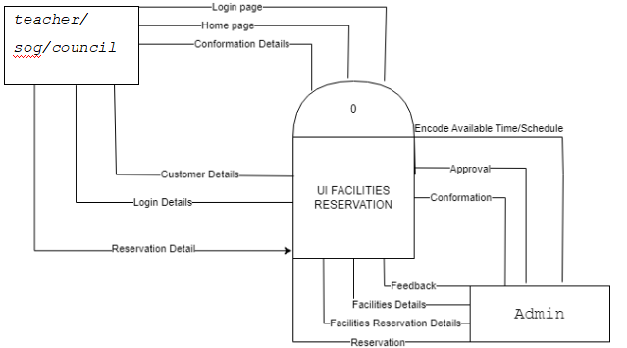

*Figure 1.0 Context Diagram*

**ANALYSIS AND DESIGN**

During the analysis and design process, various methodologies are utilized to ensure that the system effectively and efficiently achieves the desired objectives.

**ENTITY RELATIONSHIP DIAGRAM (ERD)**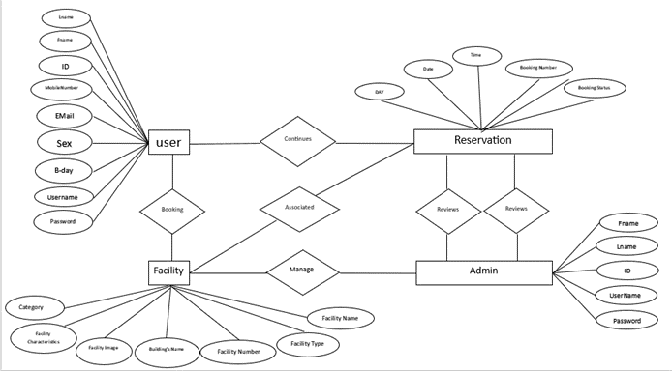

*Figure 2.0 Entity Relationship Diagram*

**DEVELOPMENT METHOD**

The proposed project is under structured analysis and uses the iterative model which is a method that represents the system in terms of processes.

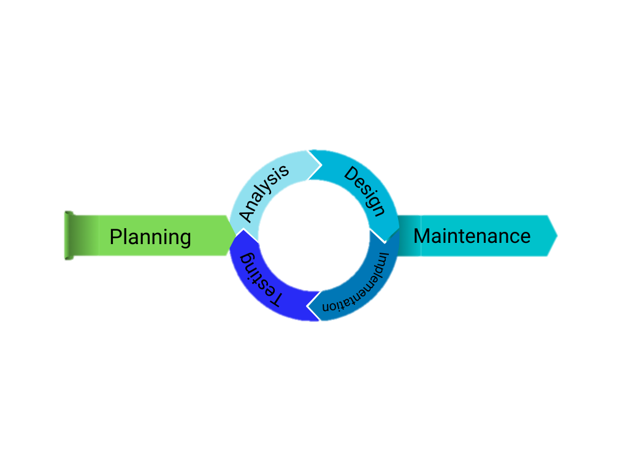

*Figure 3.0 Iterative Model*

Final software development life cycle

**PLANNING** - on the first stage we had planned what system we could develop of both parties the client to the property owner seek advantage discuss new ideas at the them both side an easy way

**ANALYSIS** – UI Facilities Reservation is a modern way or platform nowadays, making it efficient and provides the option to book a reservation venue. This system we started creating removes most of the paperwork making it an obligatory asset to have for every establishment and every property owner. Also, to create a small prototype showing how this system will work from the user side

**DESIGN** - in designing the online office space reservation app, the system design process involves creating architecture and database design in this system office space availability and location would advertise posted any social media as an attractive/ interesting form.

**IMPLEMENTATION:**

-We would like to lay down some benefits of software implementation to an end user. First thing is to enhance productivity. Second, New functionality from the old systematic tradition, more customer attracted and improved user experience, Convenience both of them (client-owner) and Notable reduction in costs tangible/intangible form.

**TESTING:**

-In this phase, Initiation phase is executed allowing for any changes necessary due to alteration in the build. From there, testing is rolled out across the users affected. It is important to roll out the testing early as testers will often be users within the business. By testing, we assure that early users can dedicate their time effectively without disrupting any day-to-day business needs that can range from an hour or two to several weeks depending on the complexity.

**MAINTENANCE**

The purpose of this phase is to modify and update software applications as well as to improve its performance. Maintenance also includes repairs or fixing the software if it breaks. With the help of this phase, we ensure to meet the satisfaction of every customer or clients who are using our application.

**SOFTWARE DEVELOPMENT TOOLS**

| Software | Specifications |
| --- | --- |
| Database | MySQL |
| Programming language | PHP, JavaScript |
| Frontend | HTML, CSS |

*Table 1.0 Software Development Tools*

**PROJECT MANAGEMENT**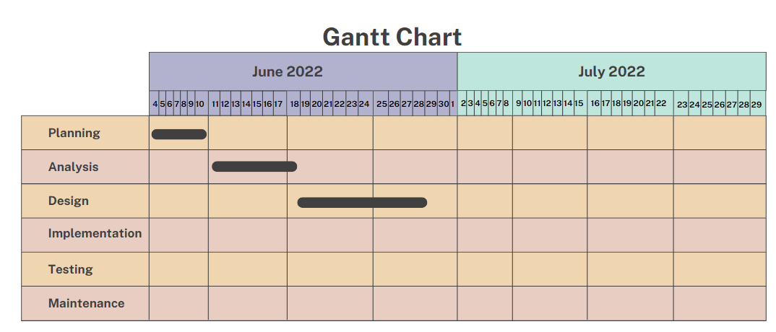

SCHEDULE AND TIMELINE

*Figure 4.0 Gantt Chart*

**TANGIBLE BENEFITS**

Tangible benefits are usually physical like equipment, material and inventory.

| **Estimated Tangible Benefits** | **Amount** |
| --- | --- |
| 2 computers | ₱ 36,000 |
| Total Tangible Benefits | ₱ 36,000 |

**INTANGIBLE BENEFITS**

* Avoid conflicts in reservation of facilities
* Manage scheduled reservation of events
* Know the availability of each facility

**PROJECT COST**

| System cost | ₱30, 000.00 |
| --- | --- |
| Domain hosting | ₱650.00 |
| Total of cost | ₱30, 650.00 |

*Table 2.0 Project Cost*

**RETURN OF INVESTMENT(ROI)**

% ROI = $\frac{Total Benefits - Total Cost}{Total Cost} x 100$

% ROI = $\frac{₱ 36,000 - ₱30,650}{₱ 30,650} x 100$

% ROI = 17%

**Chapter V**

**SYSTEM ANALYSIS**

This system can verify all the data collected, providing you with invaluable insights that you can use to improve the efficiency of every workflow. It ensures that there are no double inputs aside from reducing lost revenue, it decreases the wasted time that would have been spent on managing and fixing.

**THE PROPOSED SYSTEM**

     Facilities Reservation on its purpose is to help simplify things and manage facilities reservation such as meeting rooms, sports facilities, conference halls, auditoriums and many more in one system. This system allows to manage the occupancy, eliminates double bookings and provide insights on the facility usage with cohesive, integrated reserve solution

**FEATURES OF THE SYSTEM**

This is where a facility reservation system comes in handy. These innovative solutions help manage reservations for amenities, such as conference rooms, meeting spaces, and other types of venues. It can also offer information about the:

* space’s size and capacity.
* Quality Images helps the Users to browse through quality images of facilities, surroundings and amenities. Beautiful pictures inspire the undecided to click the "Reserve Now" button.
* Online Payment Processing this resolves the time zone issues of global travel. Immediate processing improves cash flow.

**SOFTWARE REQUIREMENTS**

| Operating System | Windows 10,11 |
| --- | --- |
| IDE | Visual Studio Code |
| Front End | HTML, CSS, JavaScript |
| Back End | PHP, MySQL, XAMPP |

*Table 3 Software Requirements*

**HARDWARE REQUIREMENTS**

| **Hardware** | **Description** |
| --- | --- |
| Input Devices | Mouse and Keyboard |
| Storage Media | 15 GB or expandable |
| Memory | 8 GB RAM expandable |

*Table 4 Hardware Requirements*

**DFD (DATA FLOW DIAGRAM)**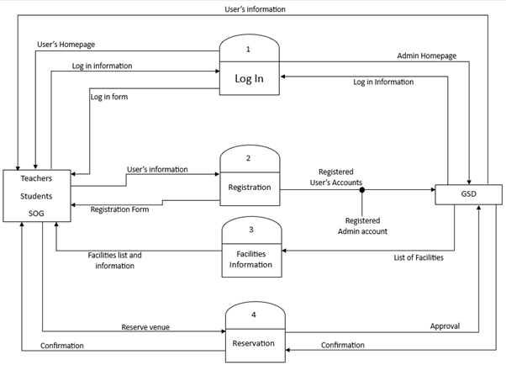

*Figure 5.0 Data Flow Diagram*

**CHILD DIAGRAM**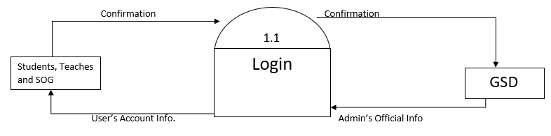

*Figure 6.1 Child Diagram (Login Information)*

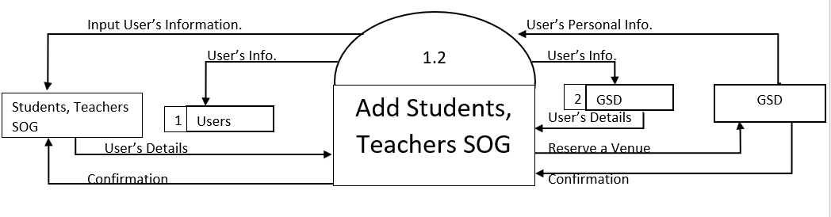

*Figure 6.2 Child Diagram (Add Entity)*

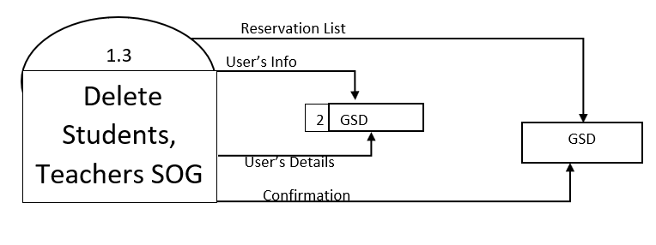

*Figure 6.3 Child Diagram (Delete Entity)*

*Figure 6.4 Child Diagram (Update Entity)*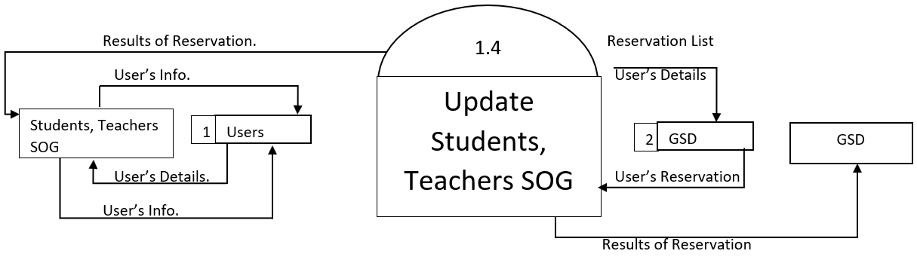

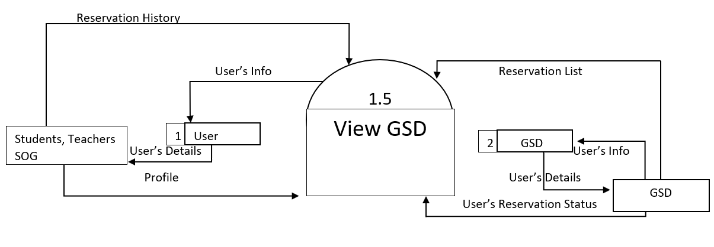

*Figure 6.5 Child Diagram (View Admin)*

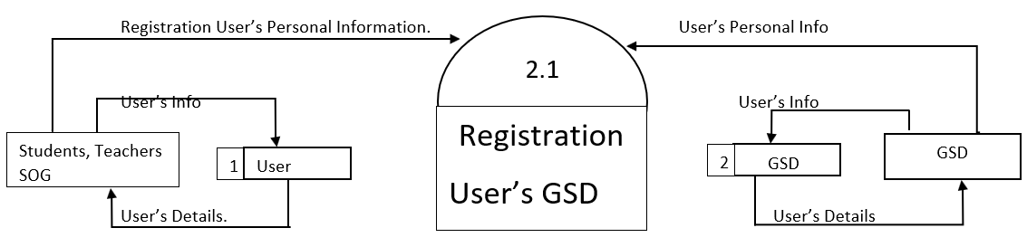

*Figure 6.6 Child Diagram (Register Admin)*

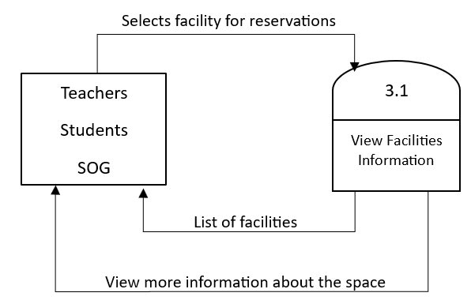

*Figure 6.7 Child Diagram (View Information)*

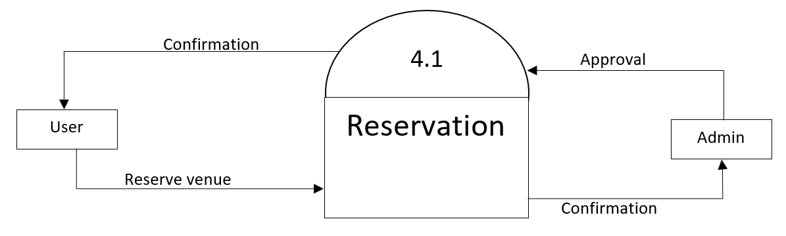

*Figure 6.8 Child Diagram (Reservation)*

**DATA ELEMENTS**

**Data element (admin)**

| Data element | Data type | Accepted value |
| --- | --- | --- |
| id | int | 255 |
| name | varchar | 255 |
| Password | varchar | 255 |
| contact | varchar | 255 |
| email | varchar | 255 |
| address | varchar | 255 |

*Table 5.1 Data element (admin)*

**Data element (SOG)**

| Data element | Data type | Accepted value |
| --- | --- | --- |
| id | int | 255 |
| name | varchar | 255 |
| Password | varchar | 255 |
| contact | varchar | 255 |
| email | varchar | 255 |
| address | varchar | 255 |

*Table 5.2 Data element (SOG)*

**Data element (Teacher)**

| Data element | Data type | Accepted value |
| --- | --- | --- |
| id | int | 255 |
| name | varchar | 255 |
| Password | varchar | 255 |
| contact | varchar | 255 |
| email | varchar | 255 |
| address | varchar | 255 |

*Table 5.3 Data element (Teacher)*

**Data element (Council)**

| Data element | Data type | Accepted value |
| --- | --- | --- |
| id | int | 255 |
| name | varchar | 255 |
| Password | varchar | 255 |
| contact | varchar | 255 |
| email | varchar | 255 |
| address | varchar | 255 |

*Table 5.4 Data element (Council)*

**DATA STORE**

**Data store(facilities)**

| Label:Facilities |
| --- |
| Alternative name: facilities |
| Description: Where users can view available facilities of phinma UI |
| Attribute:   * `id` int(255) NOT NULL, * `name` varchar(255) NOT NULL, * `description` text NOT NULL, * `image` varchar(255) NOT NULL |

*Table 6.1 Data Store (Facilities)*

**Data store(admin)**

| Label:Admin |
| --- |
| Alternative name:admin |
| Description:Where users can manipulate the system. |
| Attribute:   * `id` int(255) NOT NULL, * `name` varchar(255) NOT NULL, * `password` varchar(255) NOT NULL, * `contact` varchar(255) NOT NULL, * `email` varchar(255) NOT NULL, * `address` varchar(255) NOT NULL |

*Table 6.2 Data Store (Admin)*

**Data store (SOG)**

| Label:SOG |
| --- |
| Alternative name: Sog |
| Description: |
| Attribute:   * `id` int(255) NOT NULL, * `name` varchar(255) NOT NULL, * `password` varchar(255) NOT NULL, * `contact` varchar(255) NOT NULL, * `email` varchar(255) NOT NULL, * `address` varchar(255) NOT NULL |

*Table 6.3 Data Store (SOG)*

**Data store(teacher)**

| Label:Teacher/ Faculties |
| --- |
| Alternative name:teacher |
| Description: where all the teacher’s information stored. |
| Attribute:   * `id` int(255) NOT NULL, * `name` varchar(255) NOT NULL, * `password` varchar(255) NOT NULL, * `contact` varchar(255) NOT NULL, * `email` varchar(255) NOT NULL, * `address` varchar(255) NOT NULL |

*Table 6.4 Data Store (Teacher)*

**Data store(council)**

| Label:Council |
| --- |
| Alternative name:council |
| Description: where all the data of council and officer stored in. |
| Attribute:   * `id` int(255) NOT NULL, * `name` varchar(255) NOT NULL, * `password` varchar(255) NOT NULL, * `contact` varchar(255) NOT NULL, * `email` varchar(255) NOT NULL, * `address` varchar(255) NOT NULL |

*Table 6.5 Data Store (Council)*

**Chapter VI**

**SUMMARY, CONCLUSION, AND RECOMMENDATION**

**Summary**

This system provides an effortless way for beneficiaries to find suitable meeting and working space, it also provides each beneficiary a different available space which is suitable for their needs based on the size and cost.

**CONCLUSIONS**

This project can also benefit the other professionals such as the freelancers, office workers, investors and students who want a comfortable place.

**RECOMMENDATION**

The following recommendations are offered to freelancers, students and office workers. Also, they can access through applications.

Enhance features to attract customer satisfaction.

**REFERENCES**

<https://jurcon.ums.edu.my/ojums/index.php/BIMP-EAGA/article/view/3257/2157>

<https://www.ripublication.com/ijaer18/ijaerv13n9_27.pdf>

<http://www.ripublication.com>

**CHAPTER VII**

**GLOSSARY OF TERMS**

**JavaScript** - a dynamic programming language that's used for web development, web applications, game development, and lots more.

**HTML** - (Hypertext Markup Language) is the code that is used to structure a web page and its content.

**CSS** - (Cascading Style Sheets) is used to style and layout web pages.

**MySQL** - an Oracle-backed open-source relational database management system (RDBMS) based on Structured Query Language (SQL).

**Return of Investment** - A calculation of the monetary value of an investment versus its cost.

**Visual Studio Code** - a streamlined code editor with support for development operations like debugging, task running, and version control.

**BIBLIOGRAPHY**

’A--VENUE’: ONLINE VENUE RESERVATION SYSTEM FOR RECOGNIZED STUDENT ORGANIZATIONS OF ADAMSON UNIVERSITY

Reuben John A. Banogon, Ronalyn T. Battad, Nikka Alyssa B. Guevarra, Rankin C. Lapeña & Leonard L. Alejandro

IT & IS Department, Adamson University, Philippines

Developing and Implementing Web-based Online University Facilities Reservation System

Daniyah Alkhaldi, Dhai Alkhaldi, Hajer Aldossary, Mutasem k. Alsmadi, Ibrahim Al-Marashdeh,

Usama A Badawi, Muneerah Alshabanah, Daniah Alrajhi

Department of Management Information Systems, College of Applied Studies and Community Service,

Imam Abdulrahman Bin Faisal University, Al-Dammam, Saudi Arabia.

International Journal of Applied Engineering Research ISSN 0973-4562 Volume 13, Number 9 (2018) pp. 6700-6708 © Research India Publications.

**Chapter VIII**

**SCREENSHOTS**

LOGIN AS:

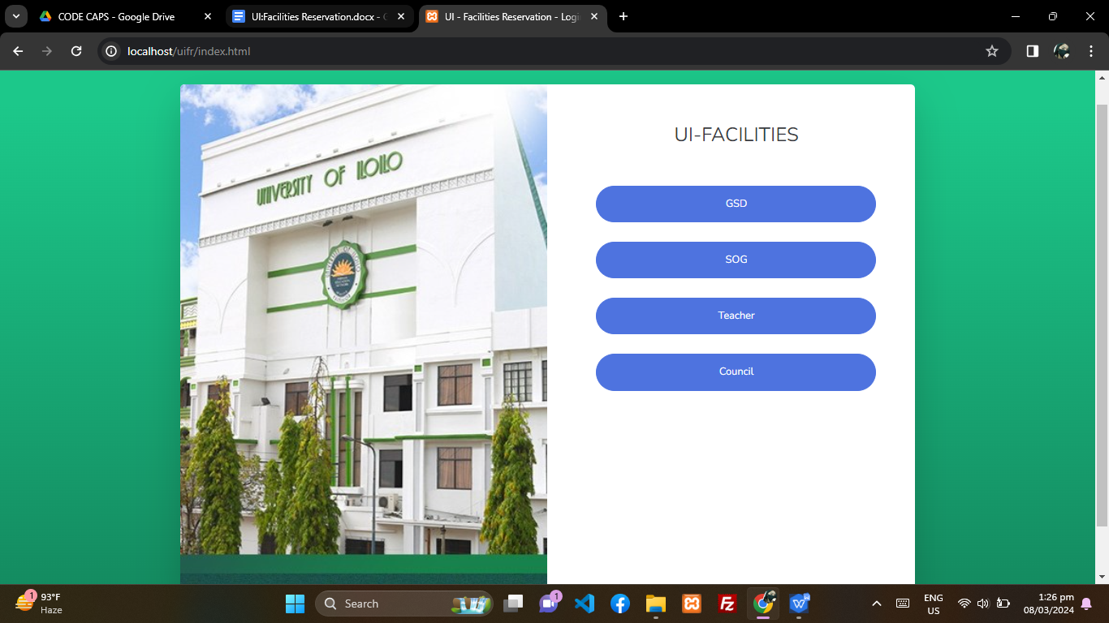

**ADMIN CALENDAR**

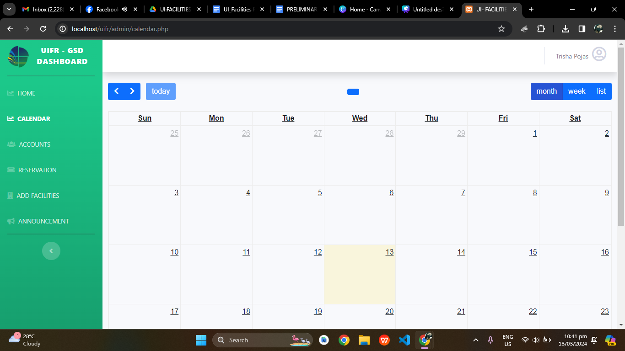

**ADMIN ACCOUNTS**

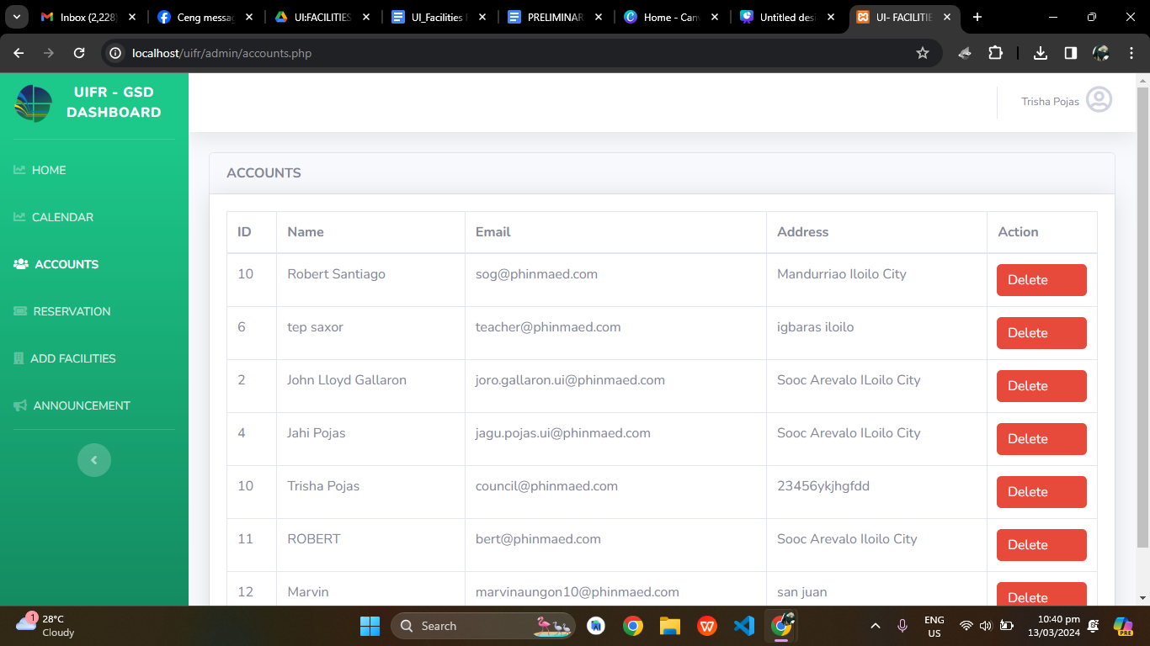

**ADMIN RESERVATION**

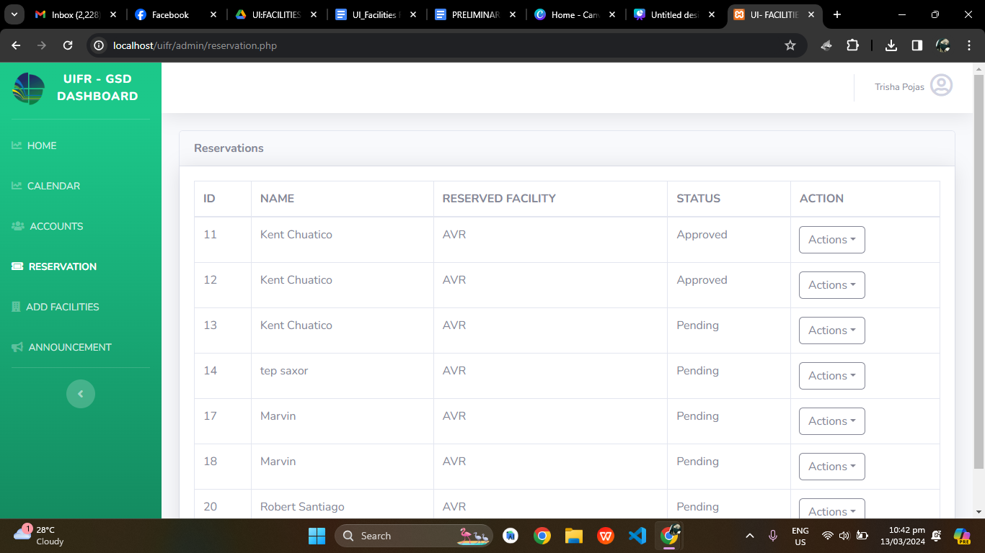

**ADMIN ADD FACILITIES**

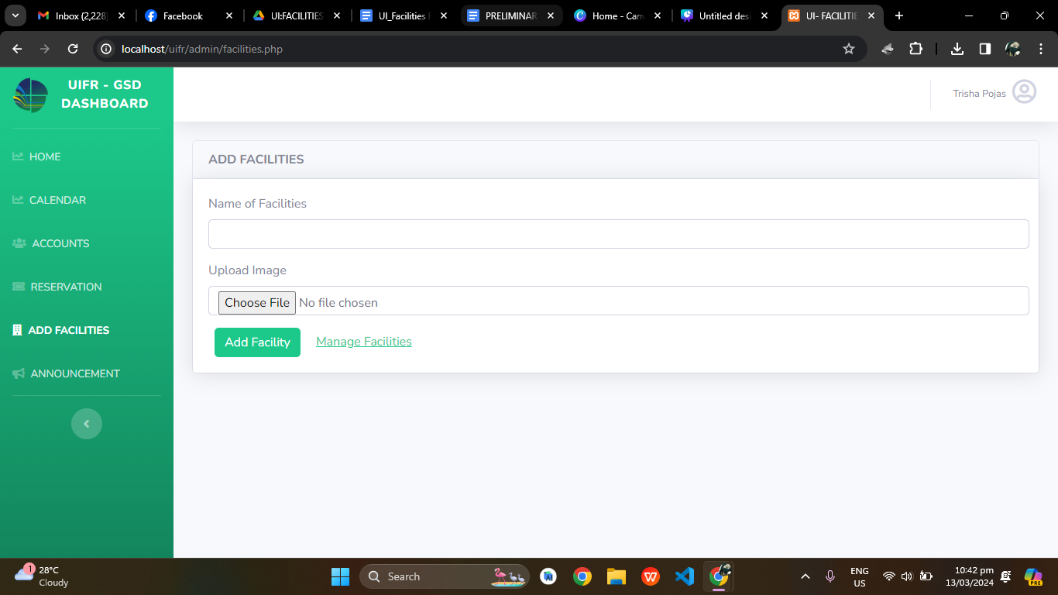

**ADMIN ANNOUNCEMENT**

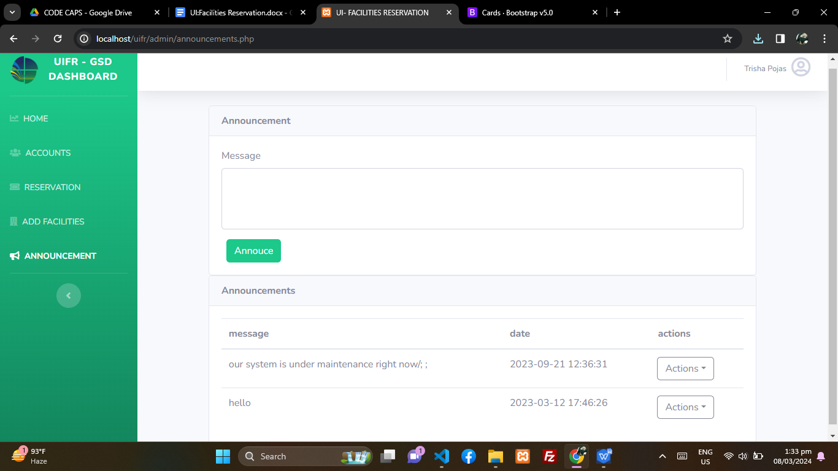

**LOG IN AS SOG:**

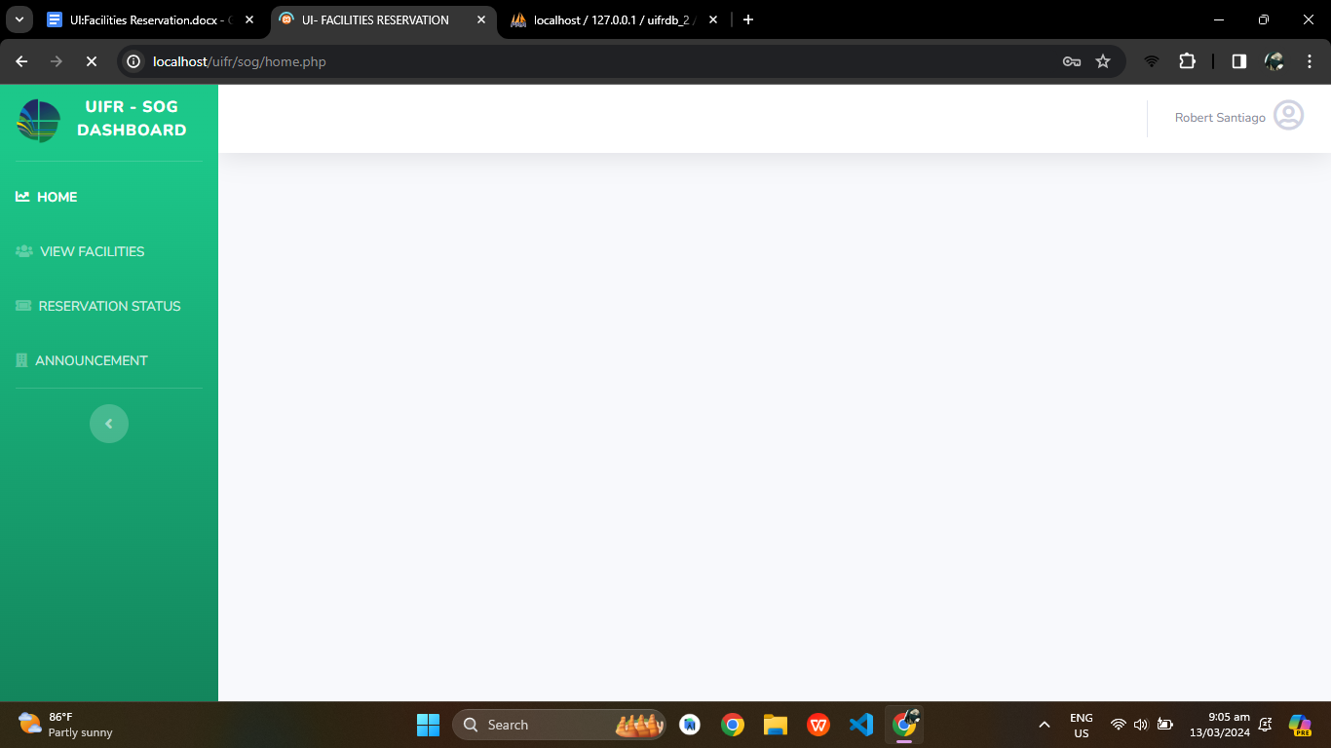

**SOG VIEW FACILITIES**

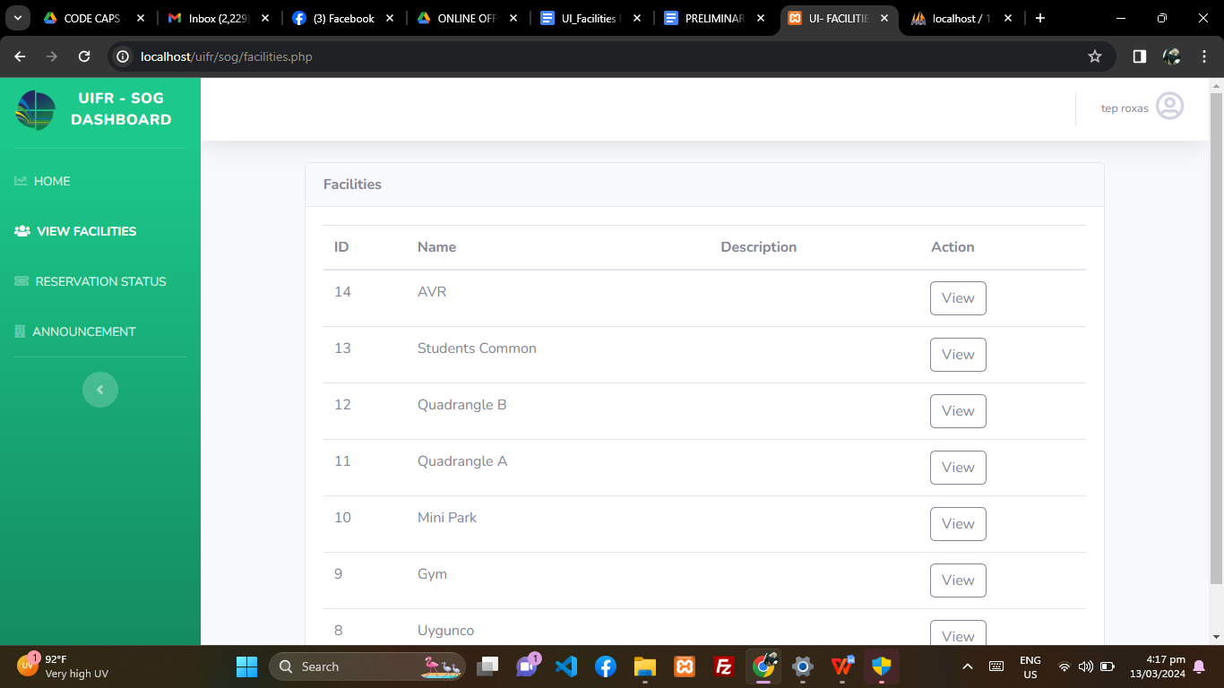

**SOG RESERVATION STATUS**

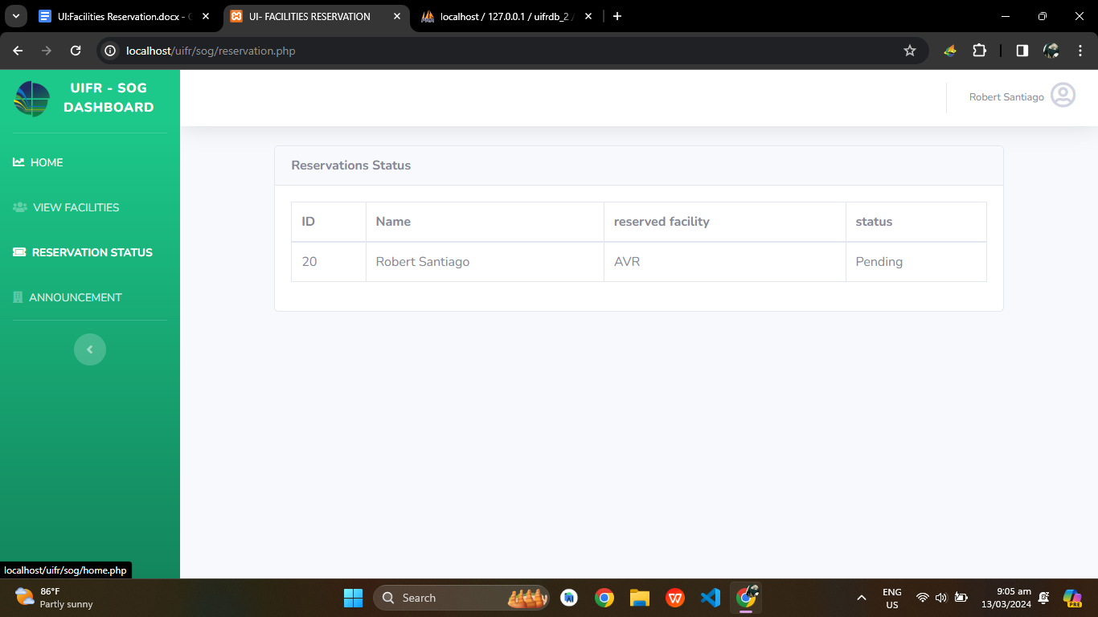

**SOG ANNOUNCEMENT**

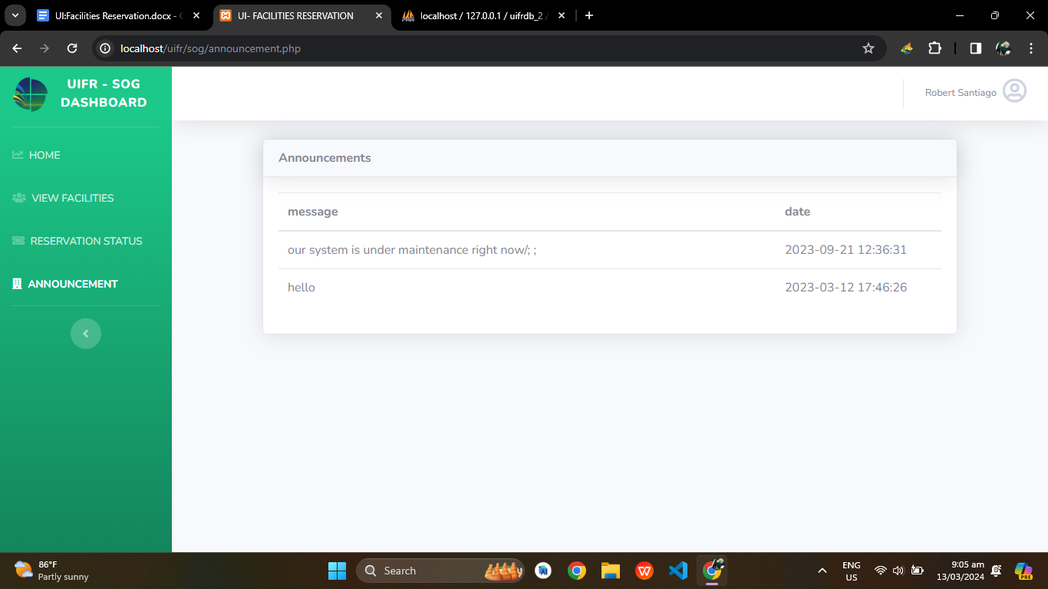

**LOGIN AS TEACHER:**

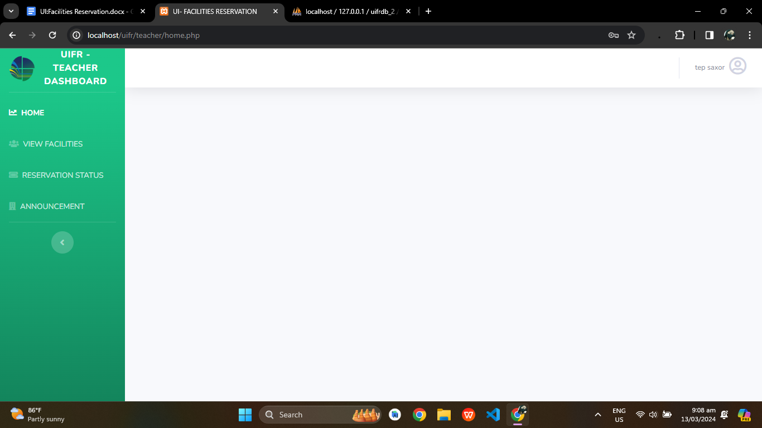

**TEACHER VIEW FACILITIES**

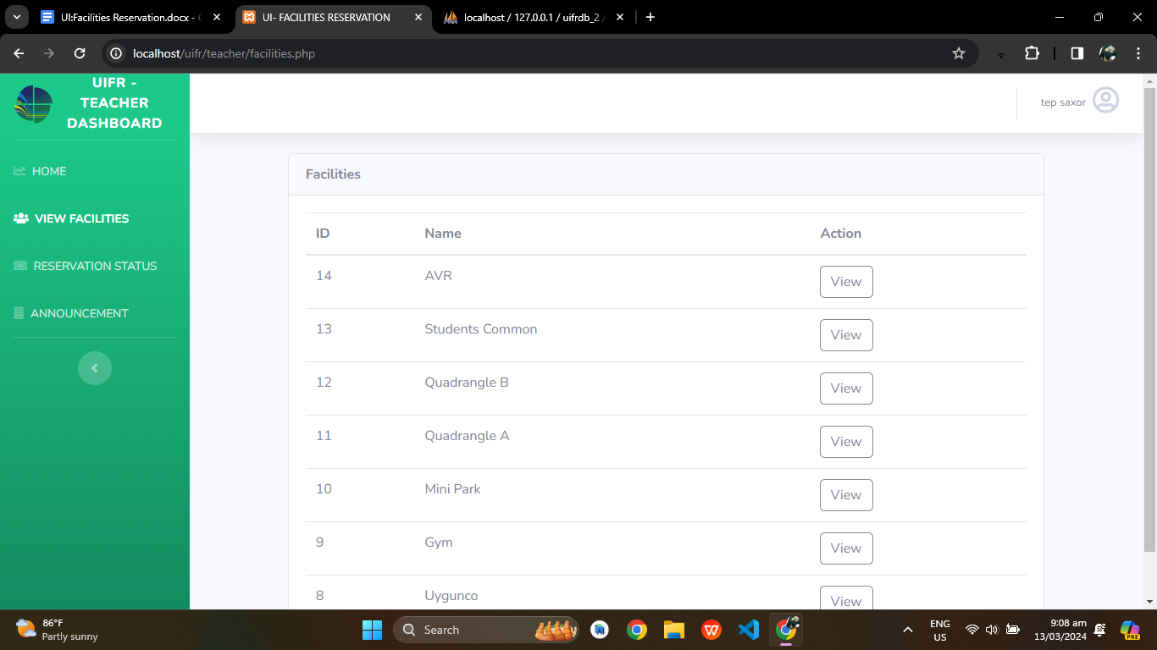

**TEACHER RESERVATION STATUS**

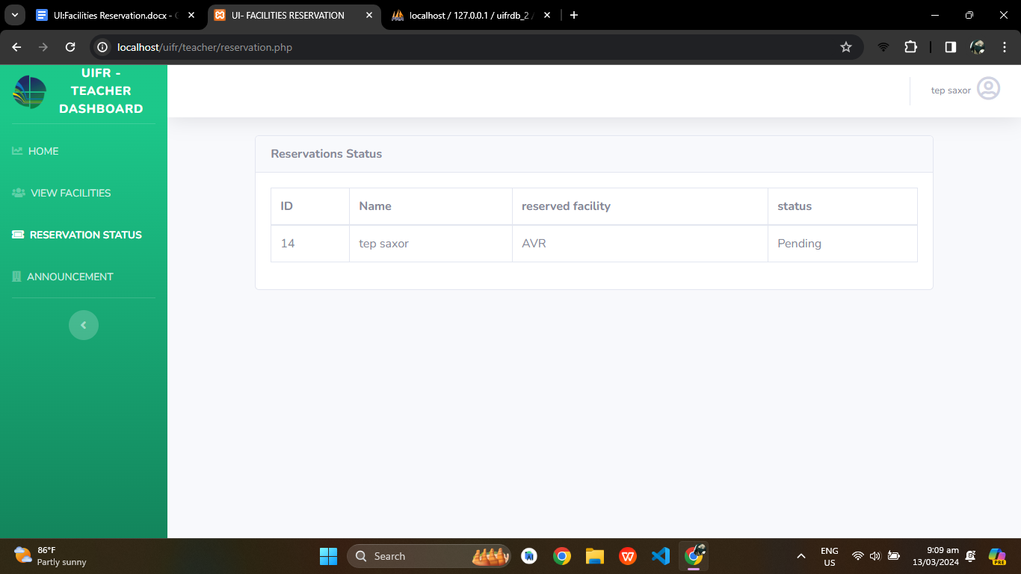

**TEACHER ANNOUNCEMENT**

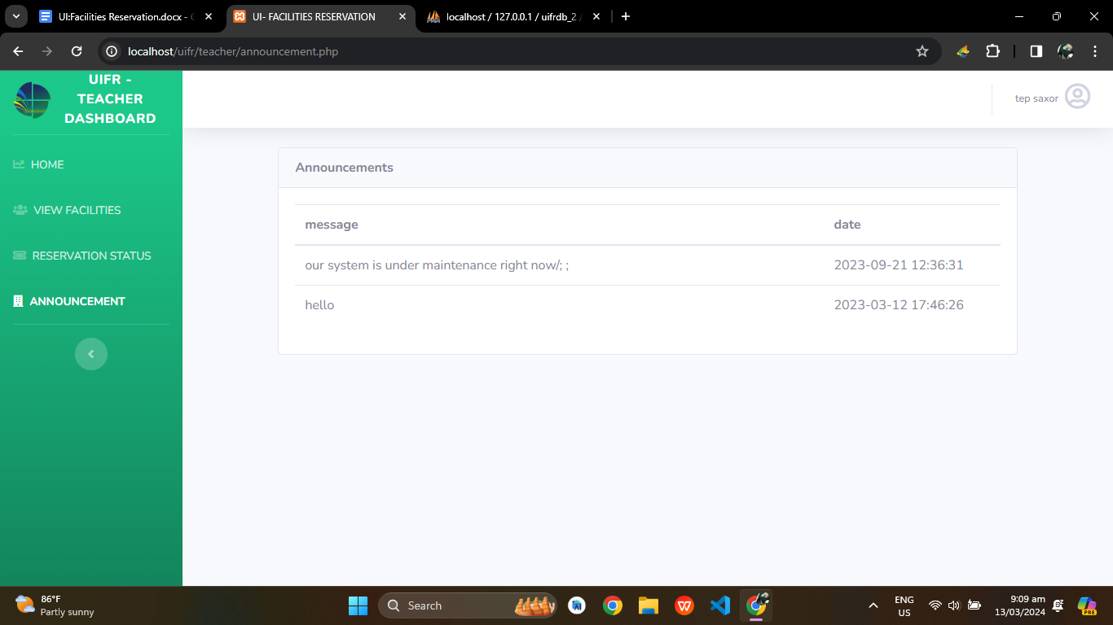

**LOGIN AS COUNCIL:**

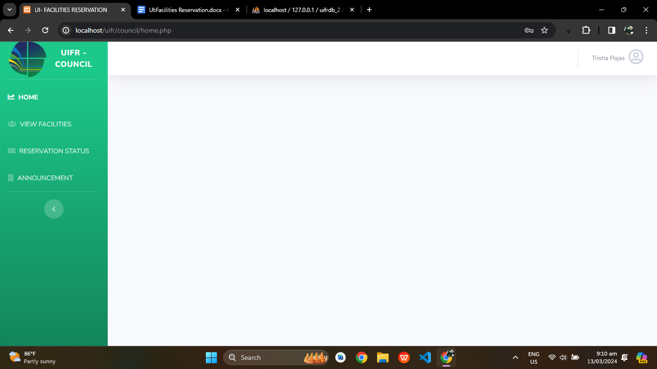

**COUNCIL VIEW FACILITIES**

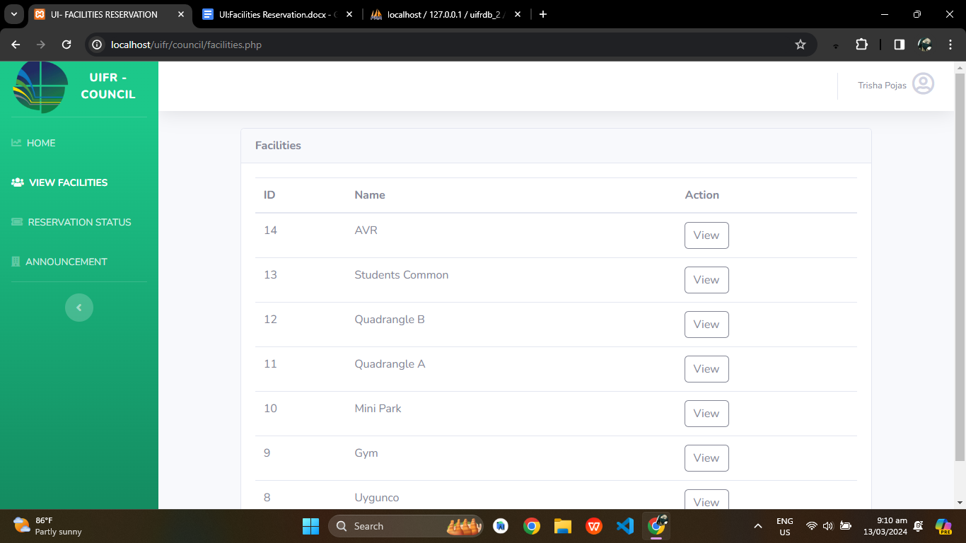

**COUNCIL RESERVATION STATUS**

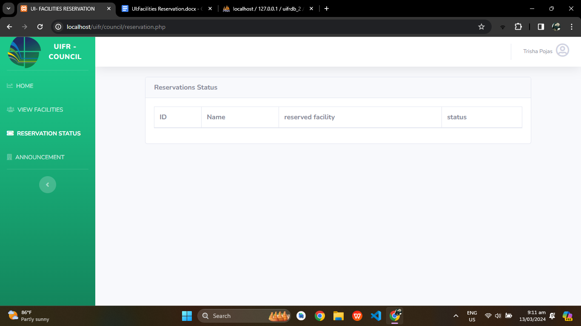

**COUNCIL ANNOUNCEMENT**

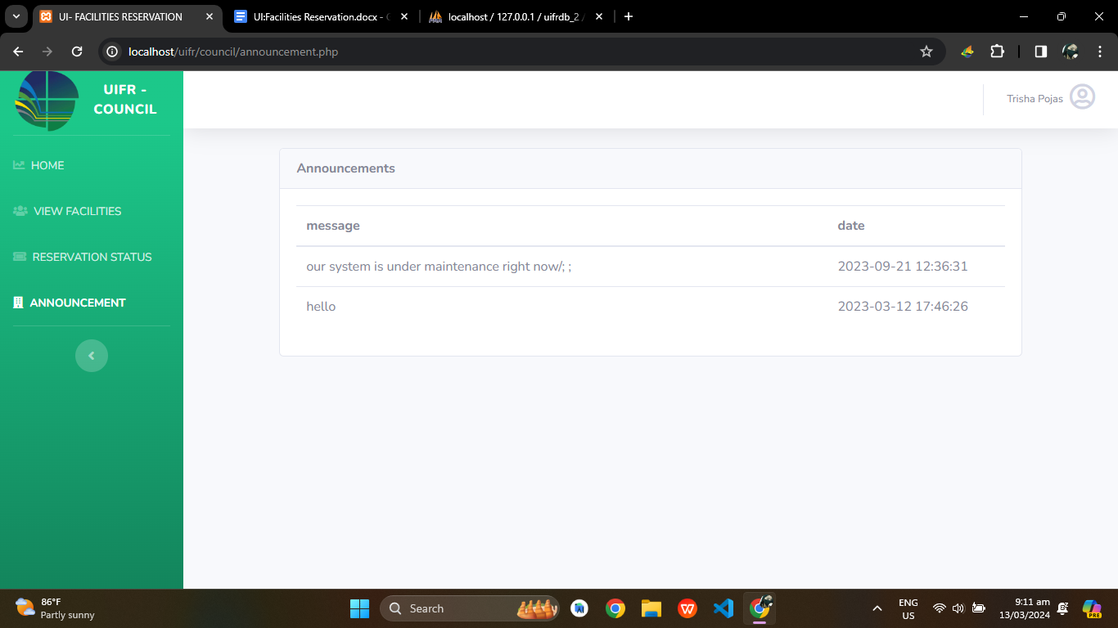

**SOURCE CODE**

<!DOCTYPE html>

<html lang="en">

<head>

<meta charset="utf-8">

<meta http-equiv="X-UA-Compatible" content="IE=edge">

<meta name="viewport" content="width=device-width, initial-scale=1, shrink-to-fit=no">

<meta name="description" content="">

<meta name="author" content="">

<title>UI - Facilities Reservation - Login</title>

<!-- Custom fonts for this template-->

<link href="admin/vendor/fontawesome-free/css/all.min.css" rel="stylesheet" type="text/css">

<link

href="https://fonts.googleapis.com/css?family=Nunito:200,200i,300,300i,400,400i,600,600i,700,700i,800,800i,900,900i"

rel="stylesheet">

<!-- Custom styles for this template-->

<link href="admin/css/sb-admin-2.min.css" rel="stylesheet">

<style>

.bg-login-image {

background: url(admin/img/phinmabg.jpg) no-repeat center;

-webkit-background-size: cover;

-moz-background-size: cover;

-o-background-size: cover;

background-size: cover;

height: 100vh;

}

</style>

</head>

<body class="bg-gradient-success">

<div class="container">

<!-- Outer Row -->

<div class="row justify-content-center">

<div class="col-xl-10 col-lg-12 col-md-9 ">

<div class="card o-hidden border-0 shadow-lg my-5">

<div class="card-body p-0">

<!-- Nested Row within Card Body -->

<div class="row">

<div class="col-lg-6 d-none d-lg-block bg-login-image"></div>

<div class="col-lg-6">

<div class="p-5">

<div class="text-center">

<h1 class="h4 text-gray-900 mb-5">UI-FACILITIES</h1>

</div>

<form action="session.php" class="user" method="POST">

<button class="btn btn-primary btn-user btn-block mb-4" type="button" onclick="window.location.href = 'admin/login.html'">

GSD

</button>

<button class="btn btn-primary btn-user btn-block mb-4" type="button" onclick="window.location.href = 'sog/login.html'">

SOG

</button>

<button class="btn btn-primary btn-user btn-block mb-4" type="button" onclick="window.location.href = 'teacher/login.html'">

Teacher

</button>

<button class="btn btn-primary btn-user btn-block mb-4" type="button" onclick="window.location.href = 'council/login.html'">

Council

</button>

</form>

</div>

</div>

</div>

</div>

</div>

</div>

</div>

</div>

<!-- Bootstrap core JavaScript-->

<script src="admin/vendor/jquery/jquery.min.js"></script>

<script src="admin/vendor/bootstrap/js/bootstrap.bundle.min.js"></script>

<!-- Core plugin JavaScript-->

<script src="vendor/jquery-easing/jquery.easing.min.js"></script>

<!-- Custom scripts for all pages-->

<script src="admin/js/sb-admin-2.min.js"></script>

</body>

</html>

**USER GUIDE**

**LOGIN INFORMATION**

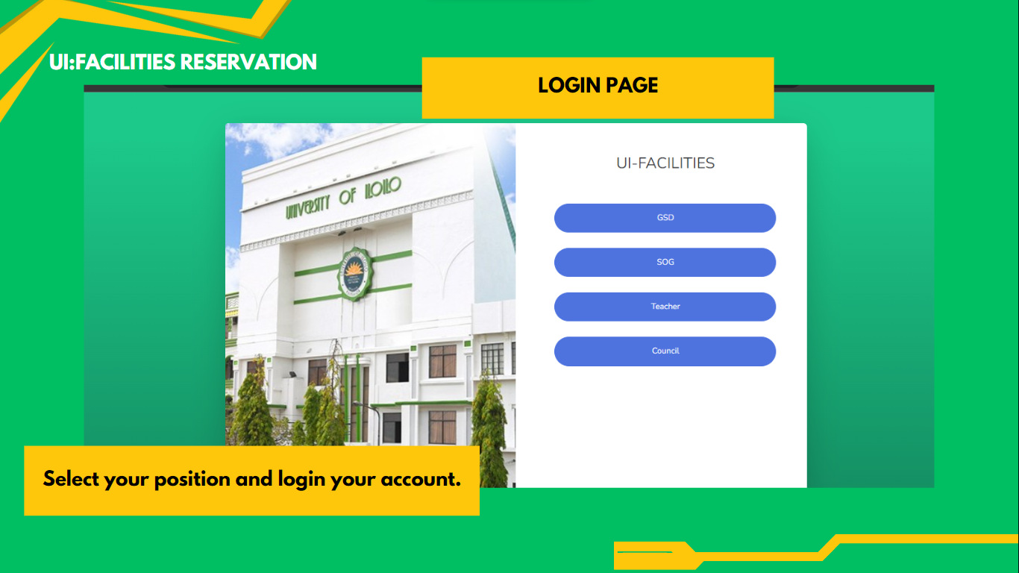

**REGISTRATION FORM**

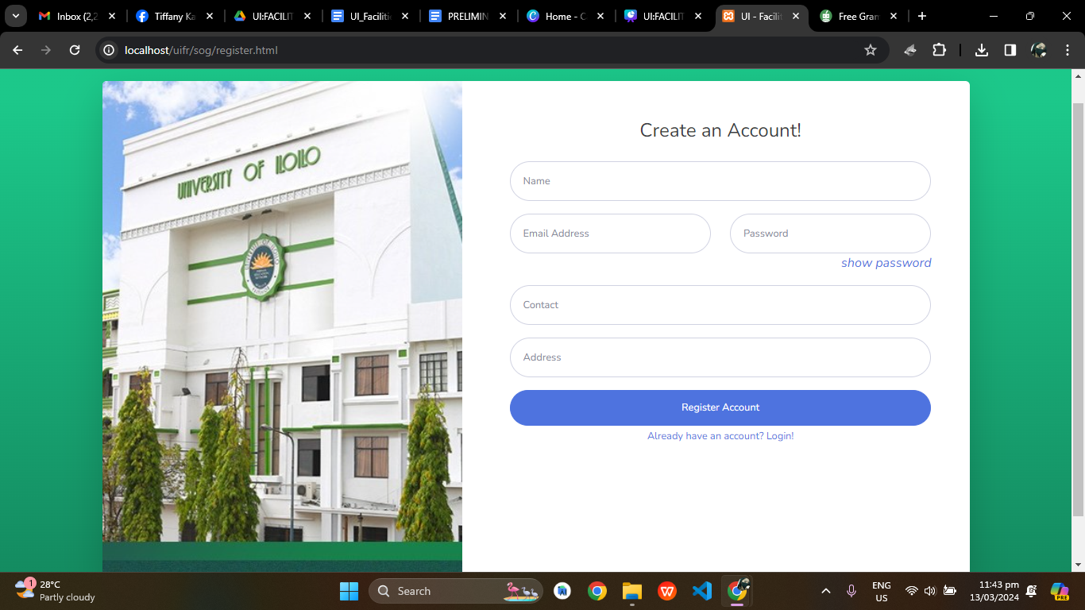

**ADMIN VIEW**

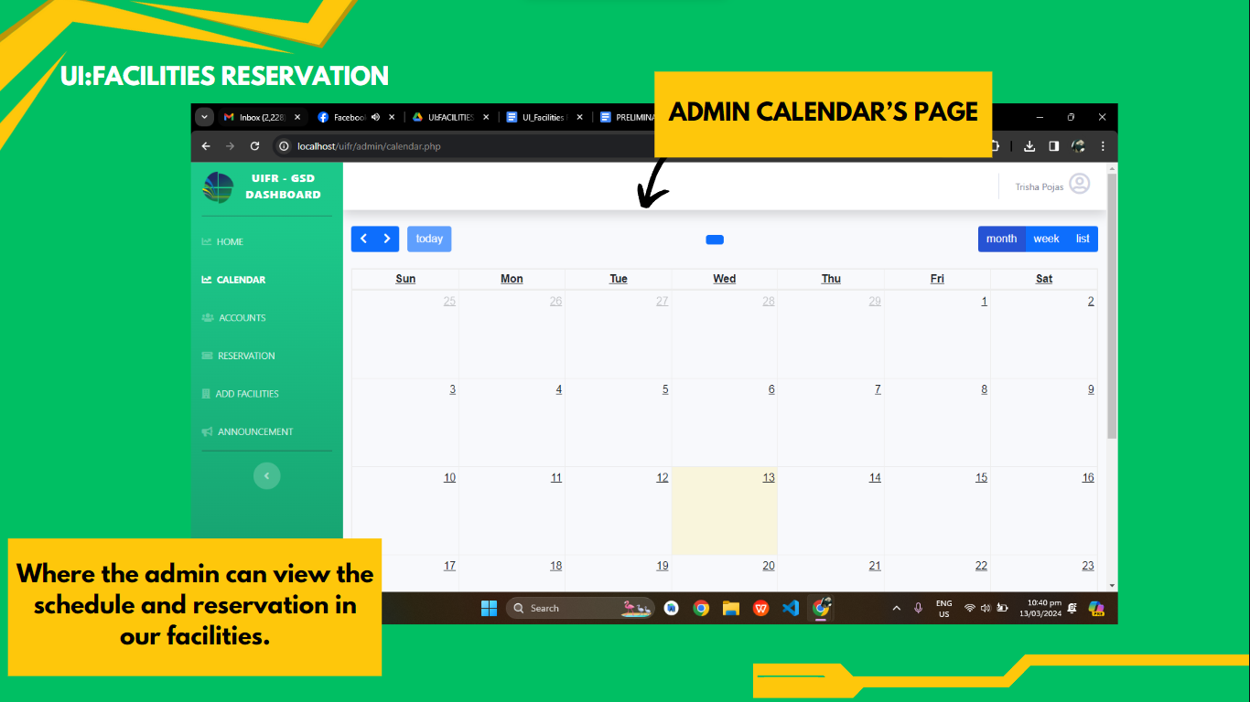

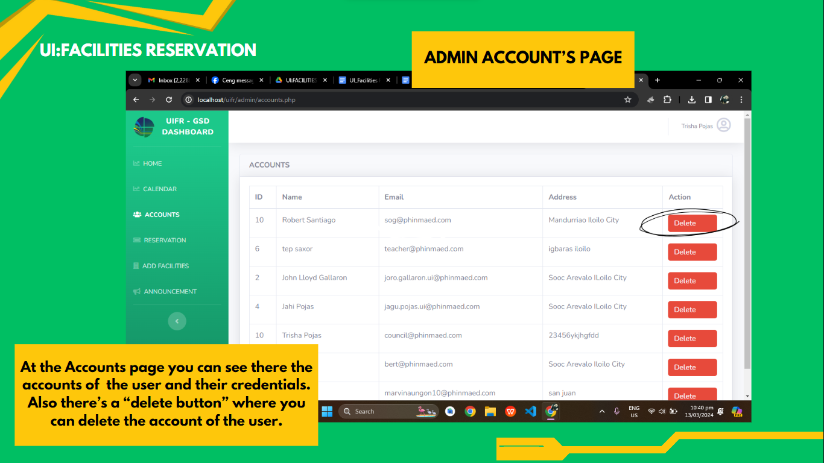

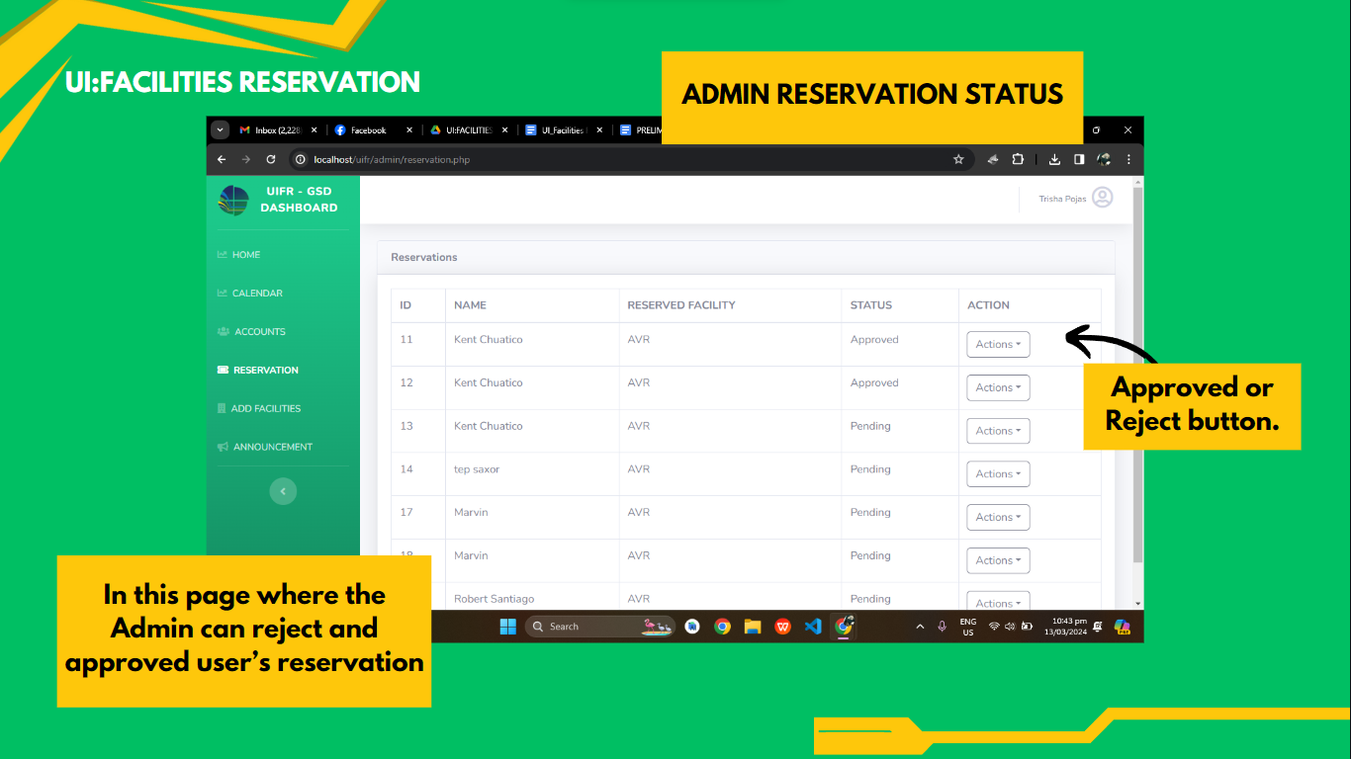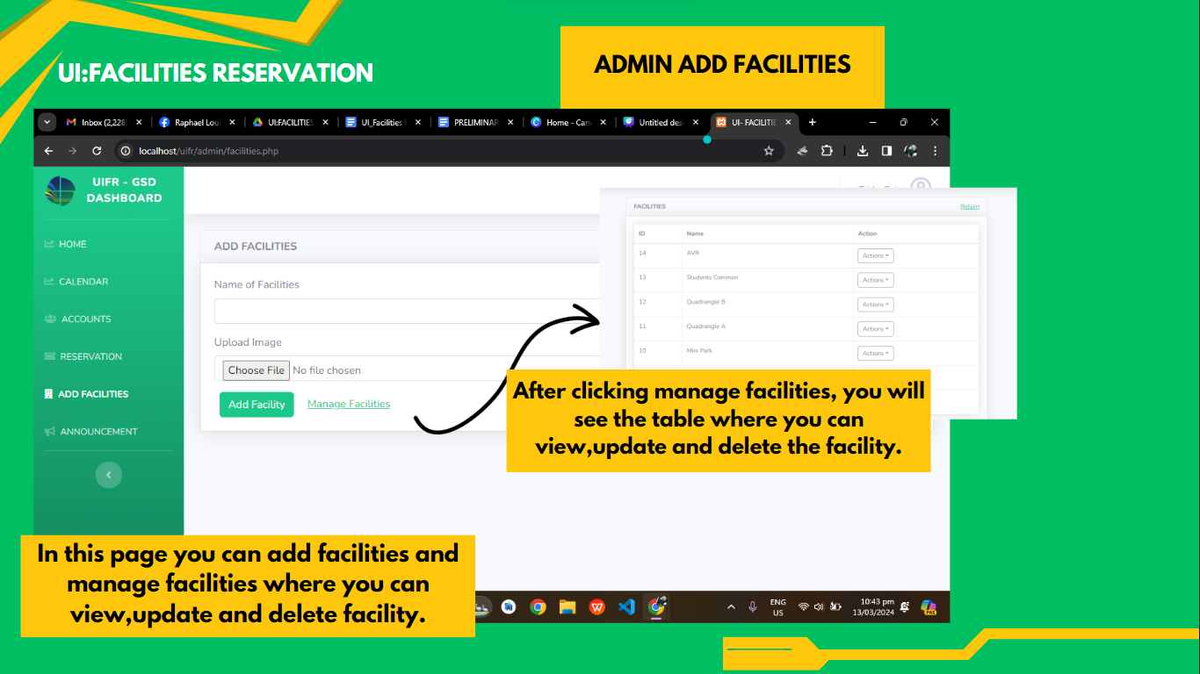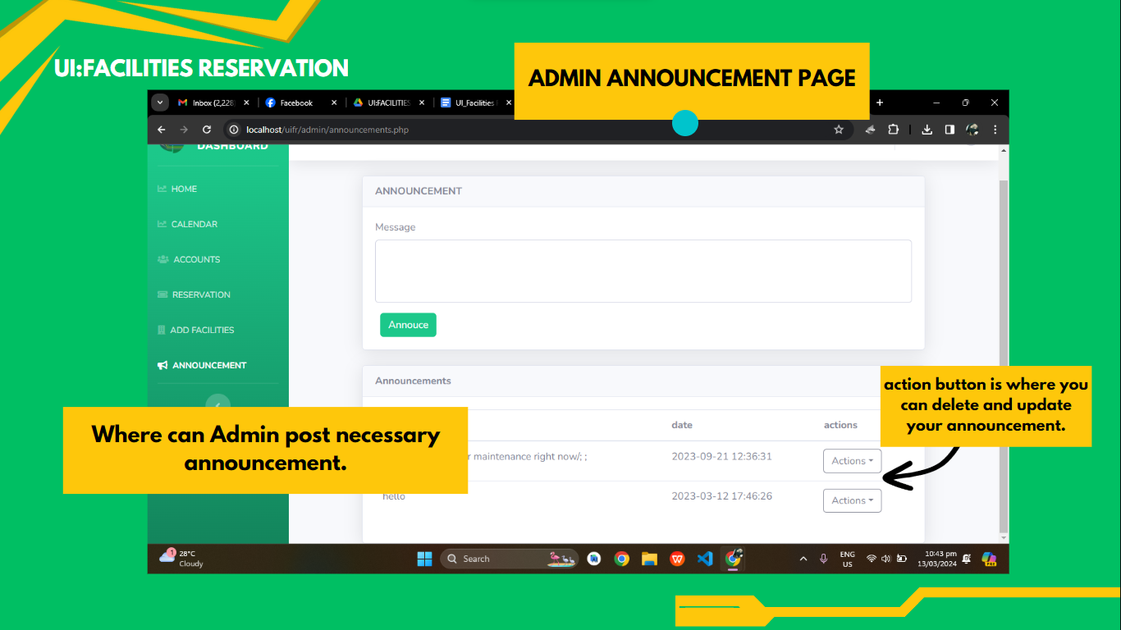

**SOG USER GUIDE**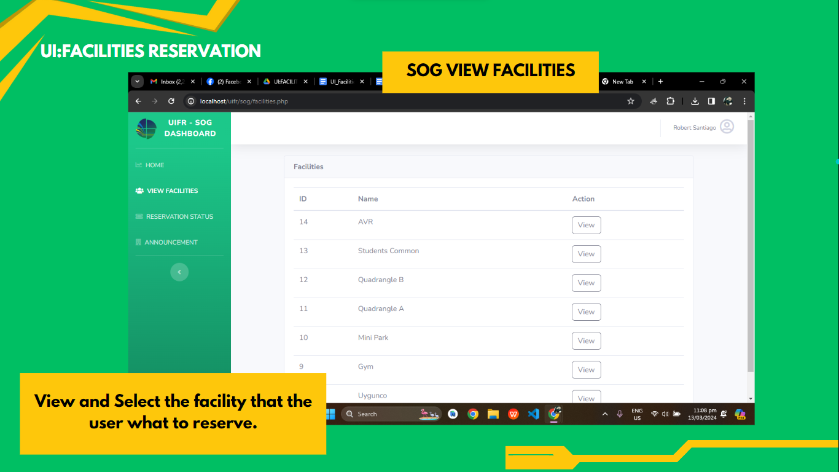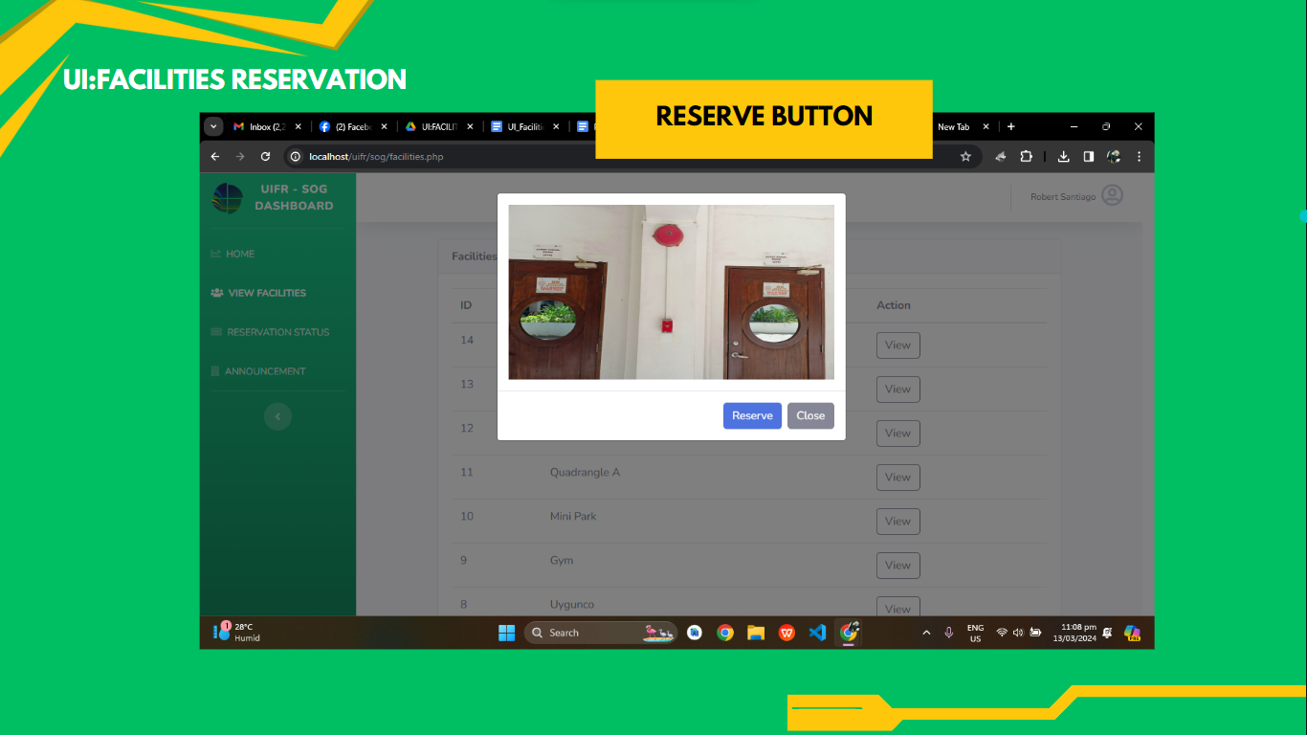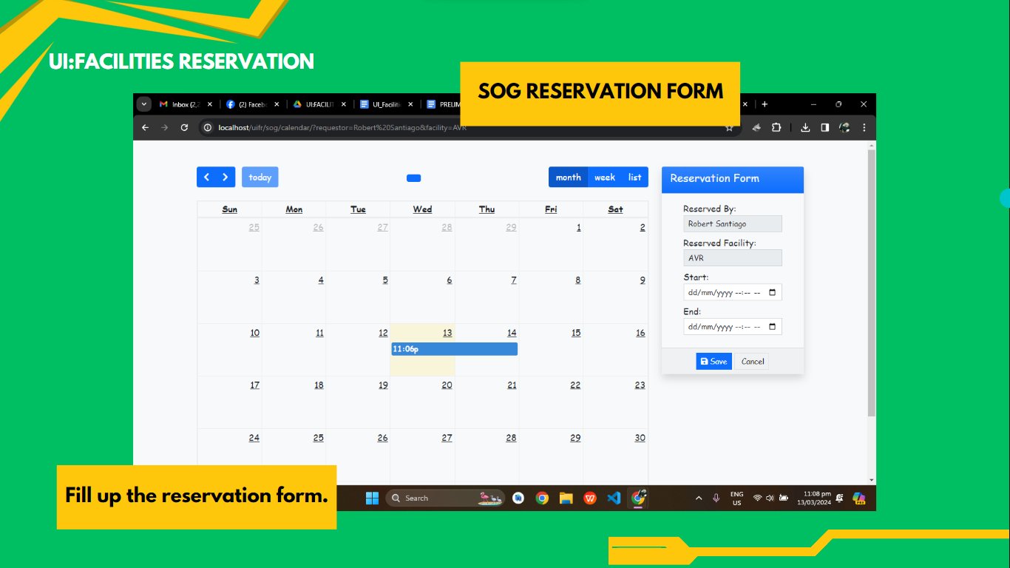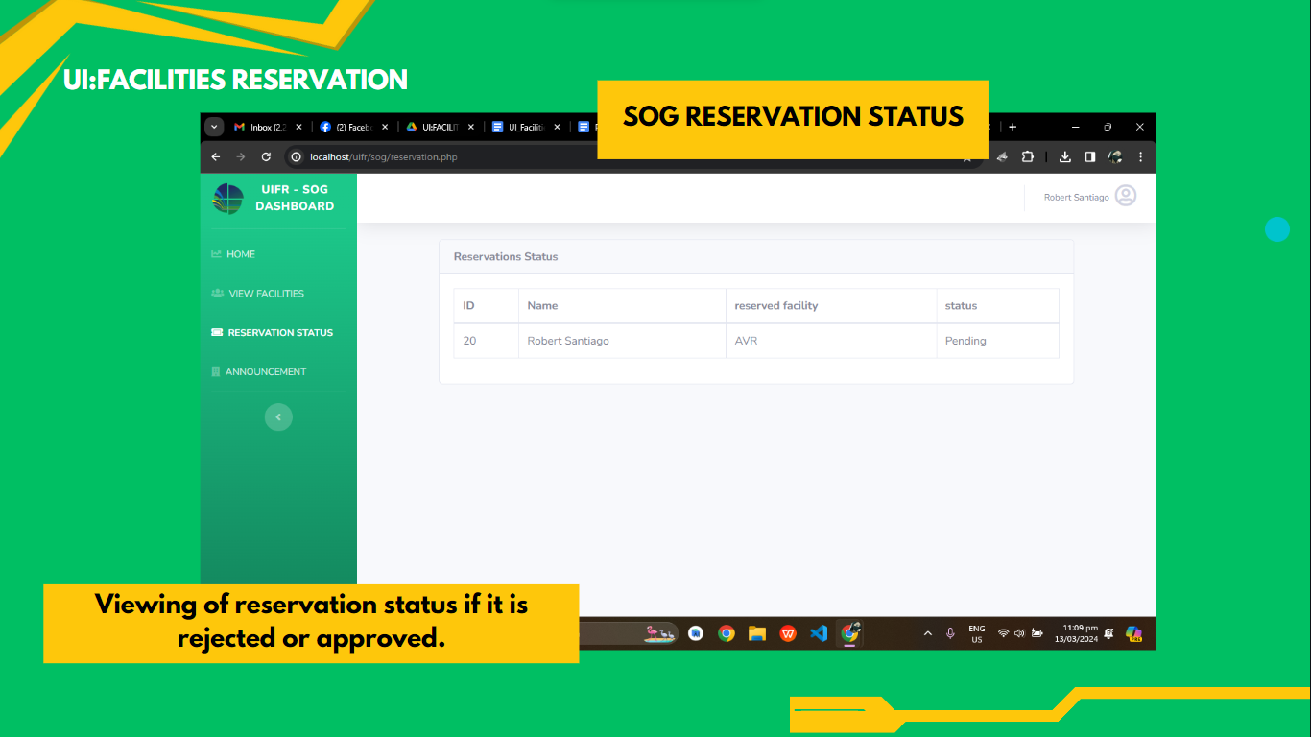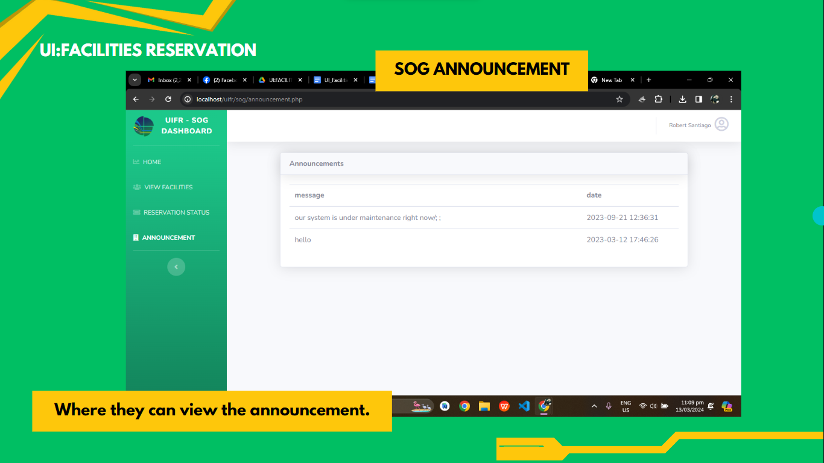

**TEACHER USER GUIDE**

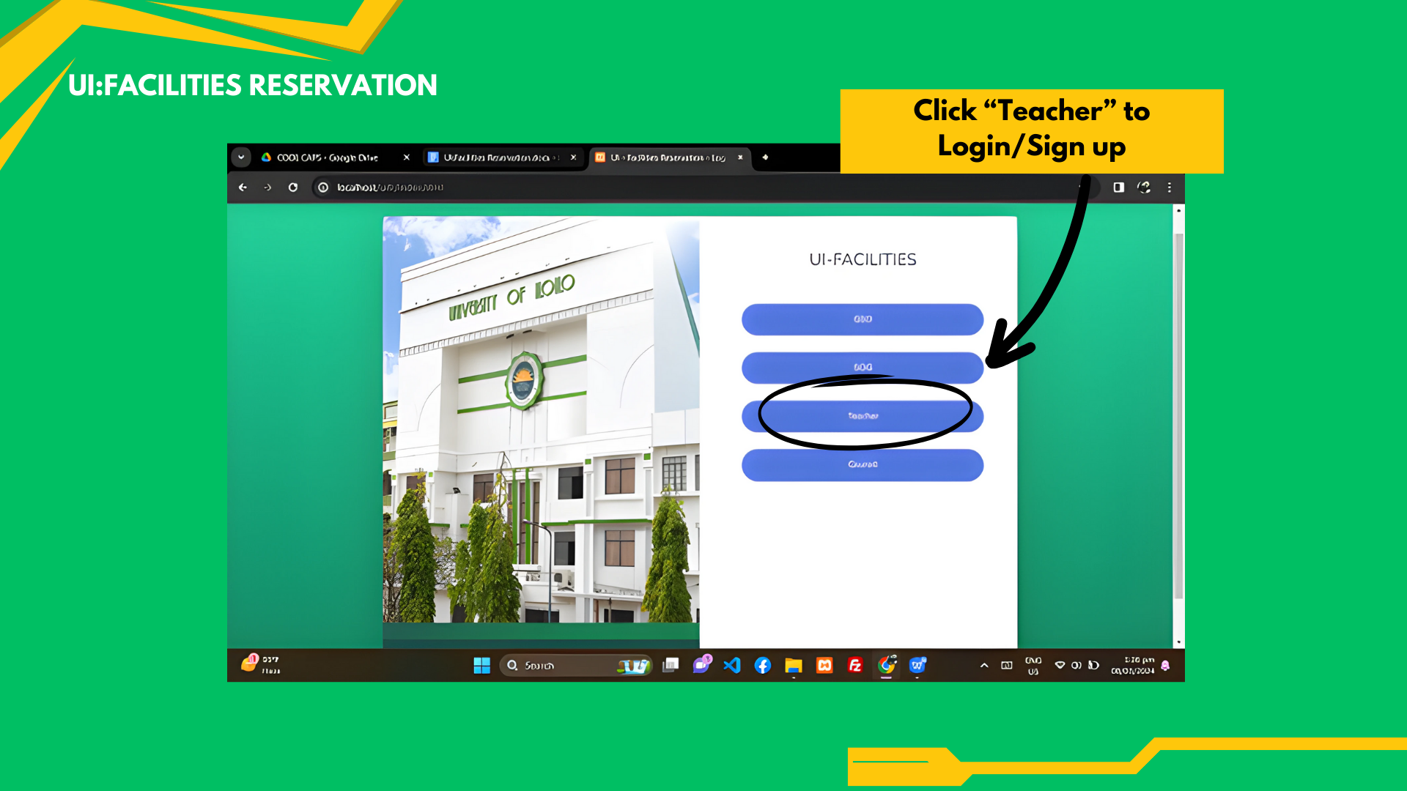

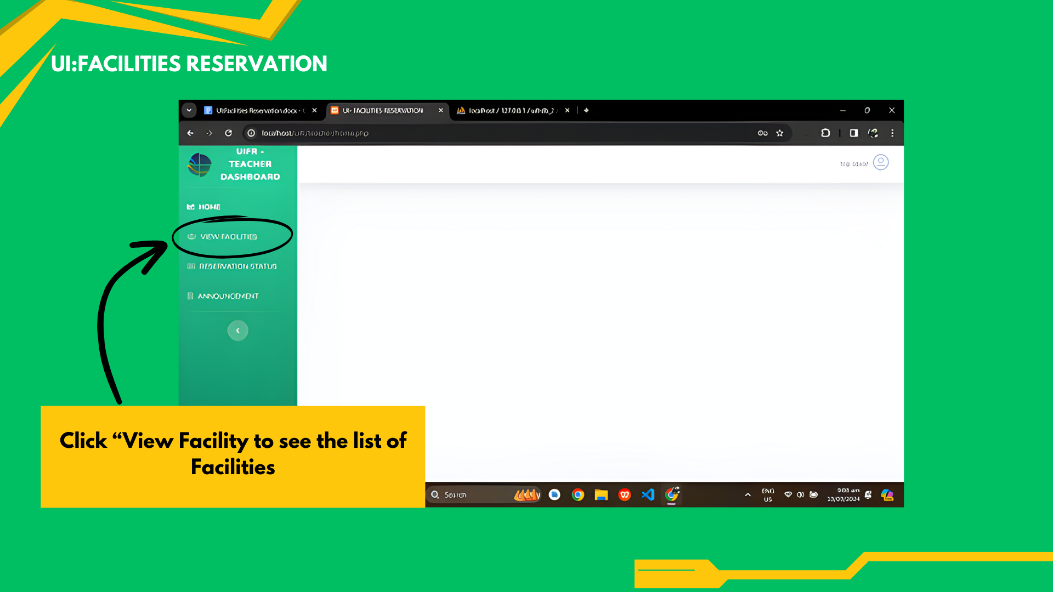

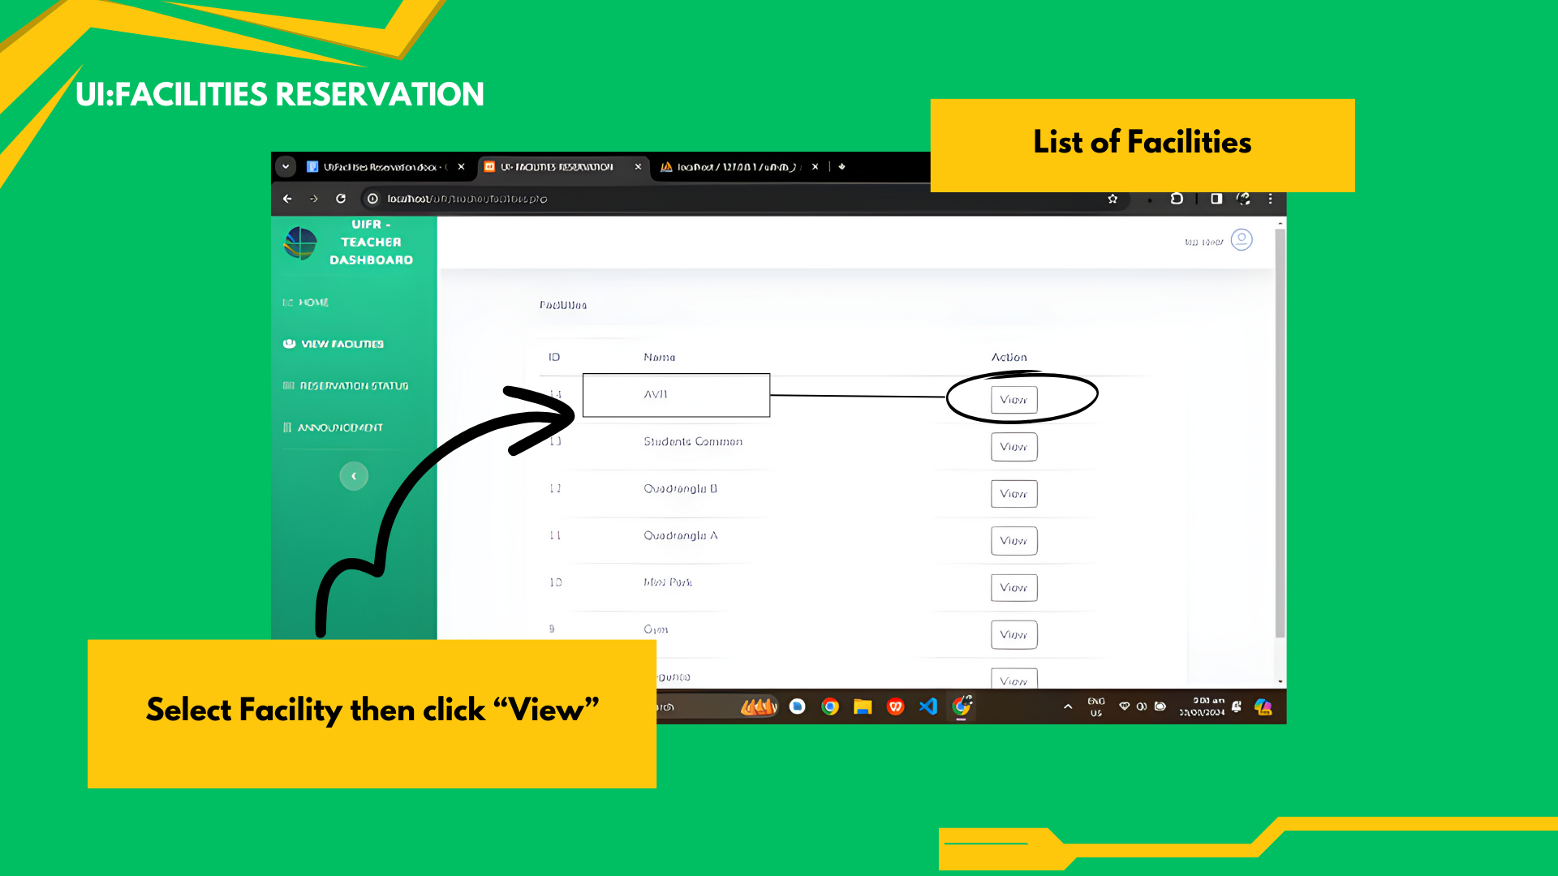

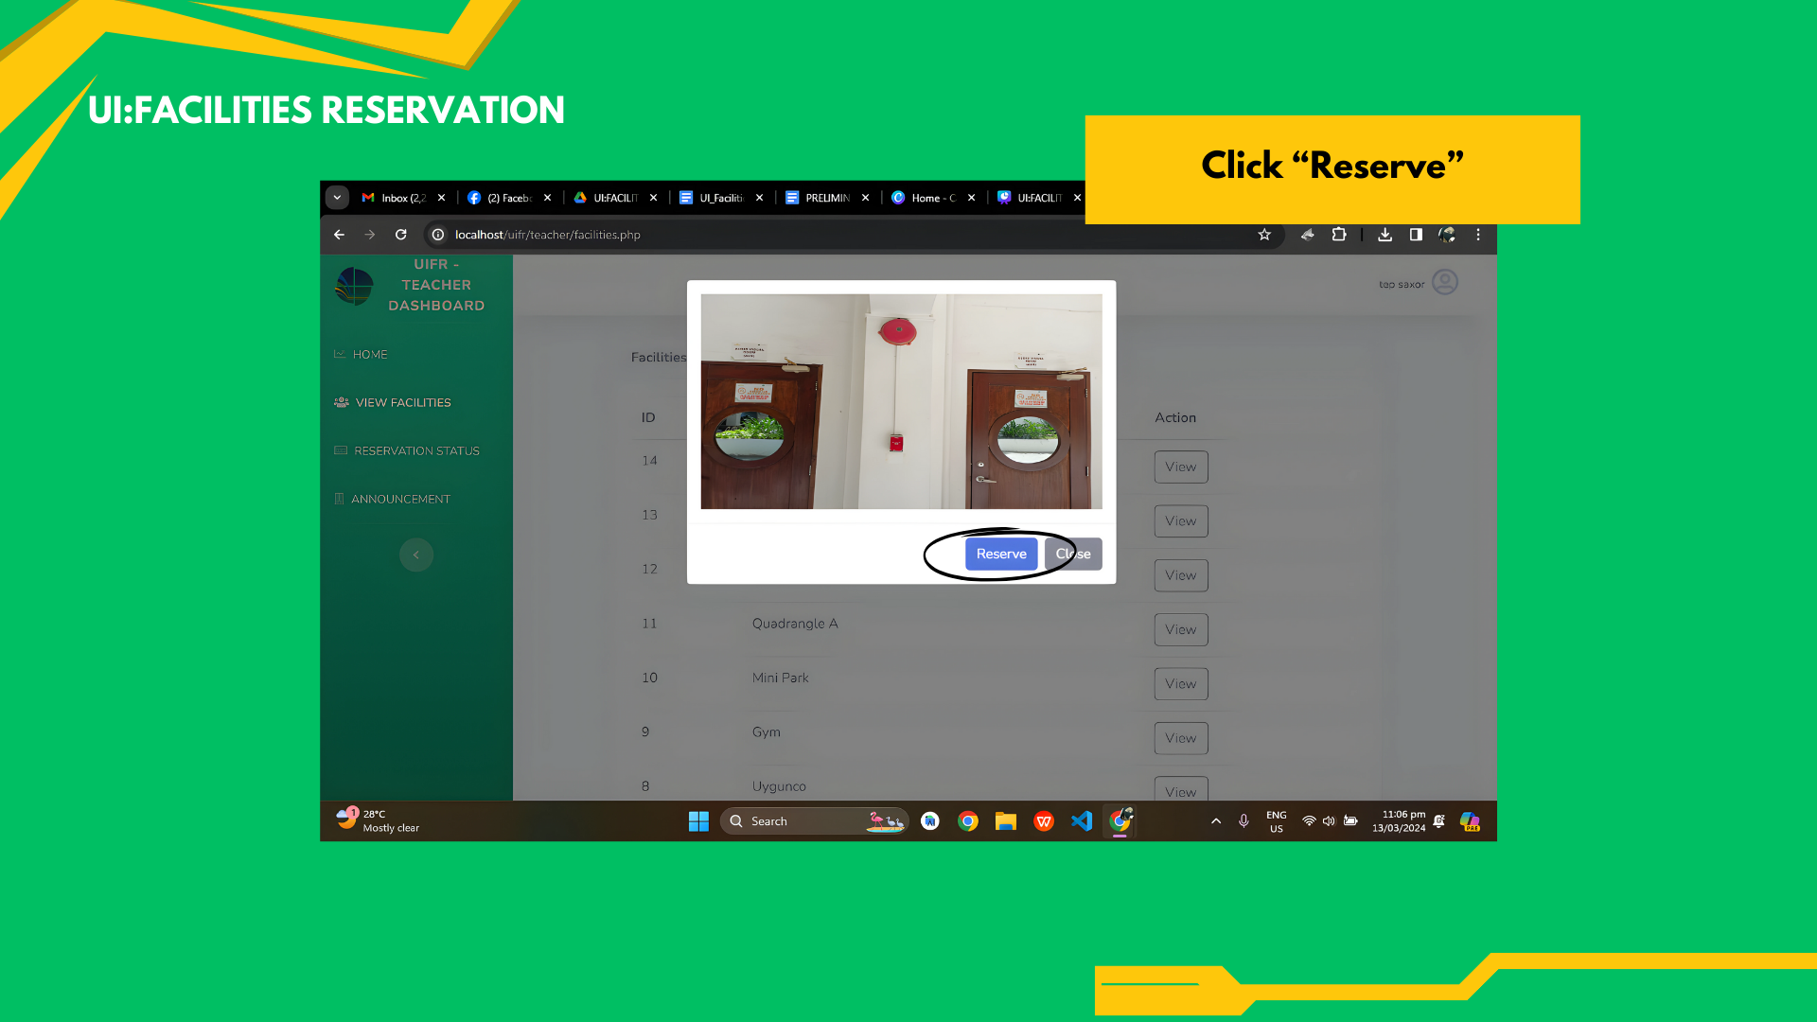

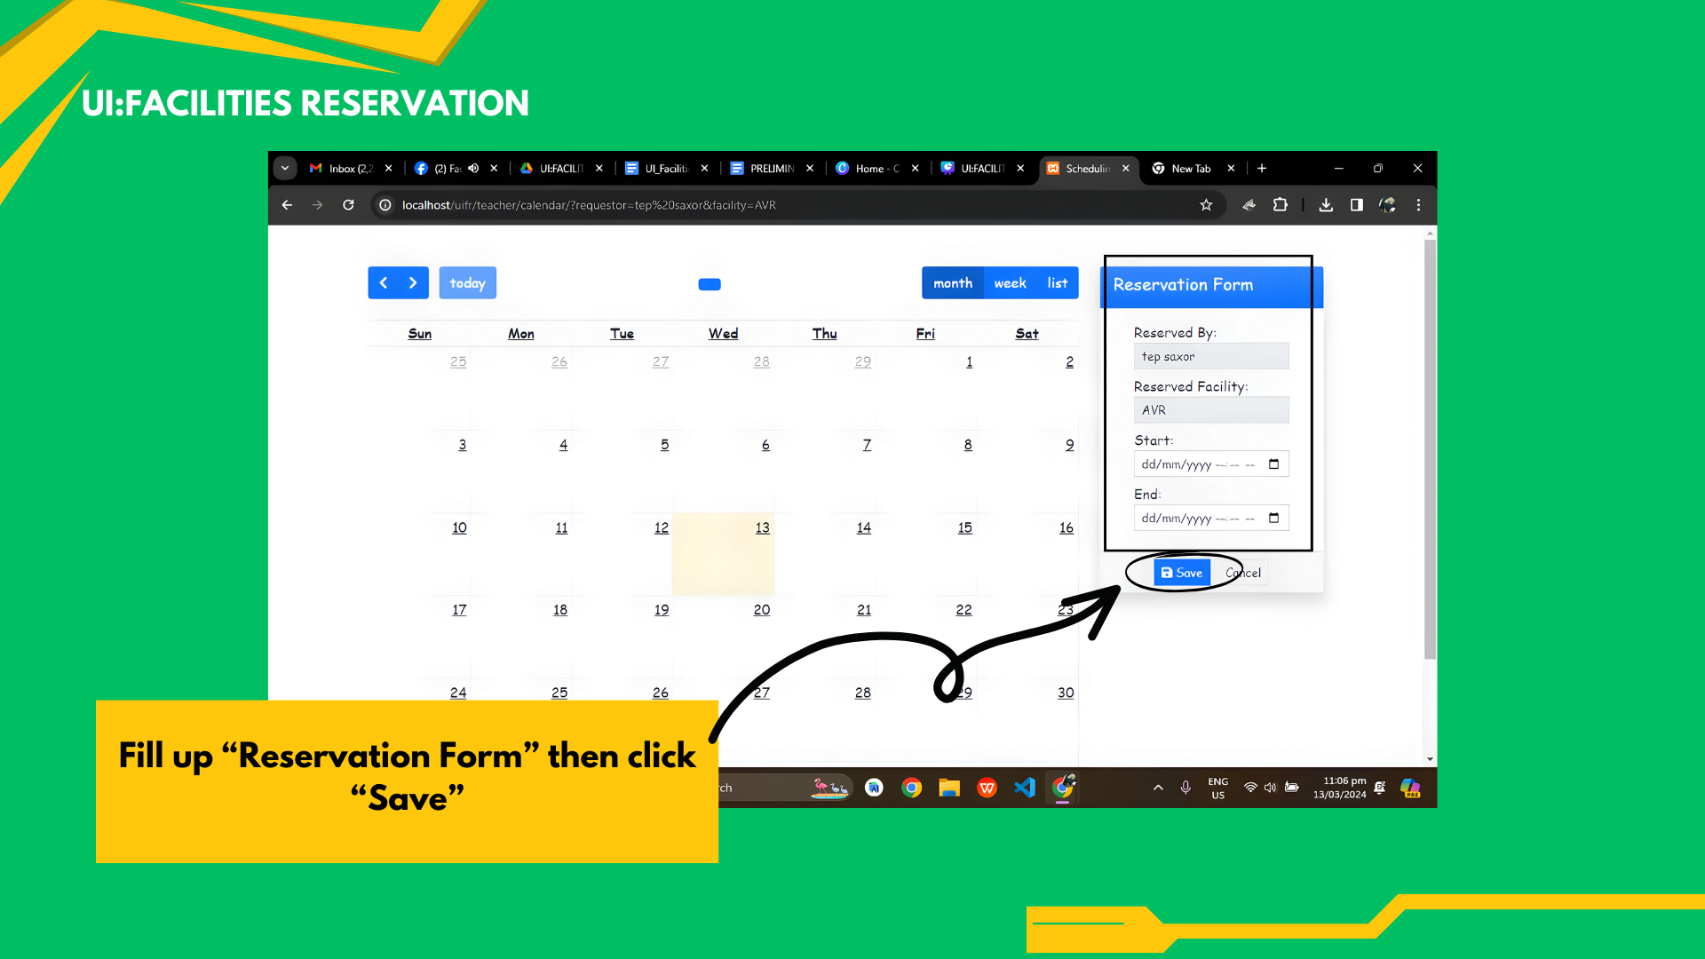

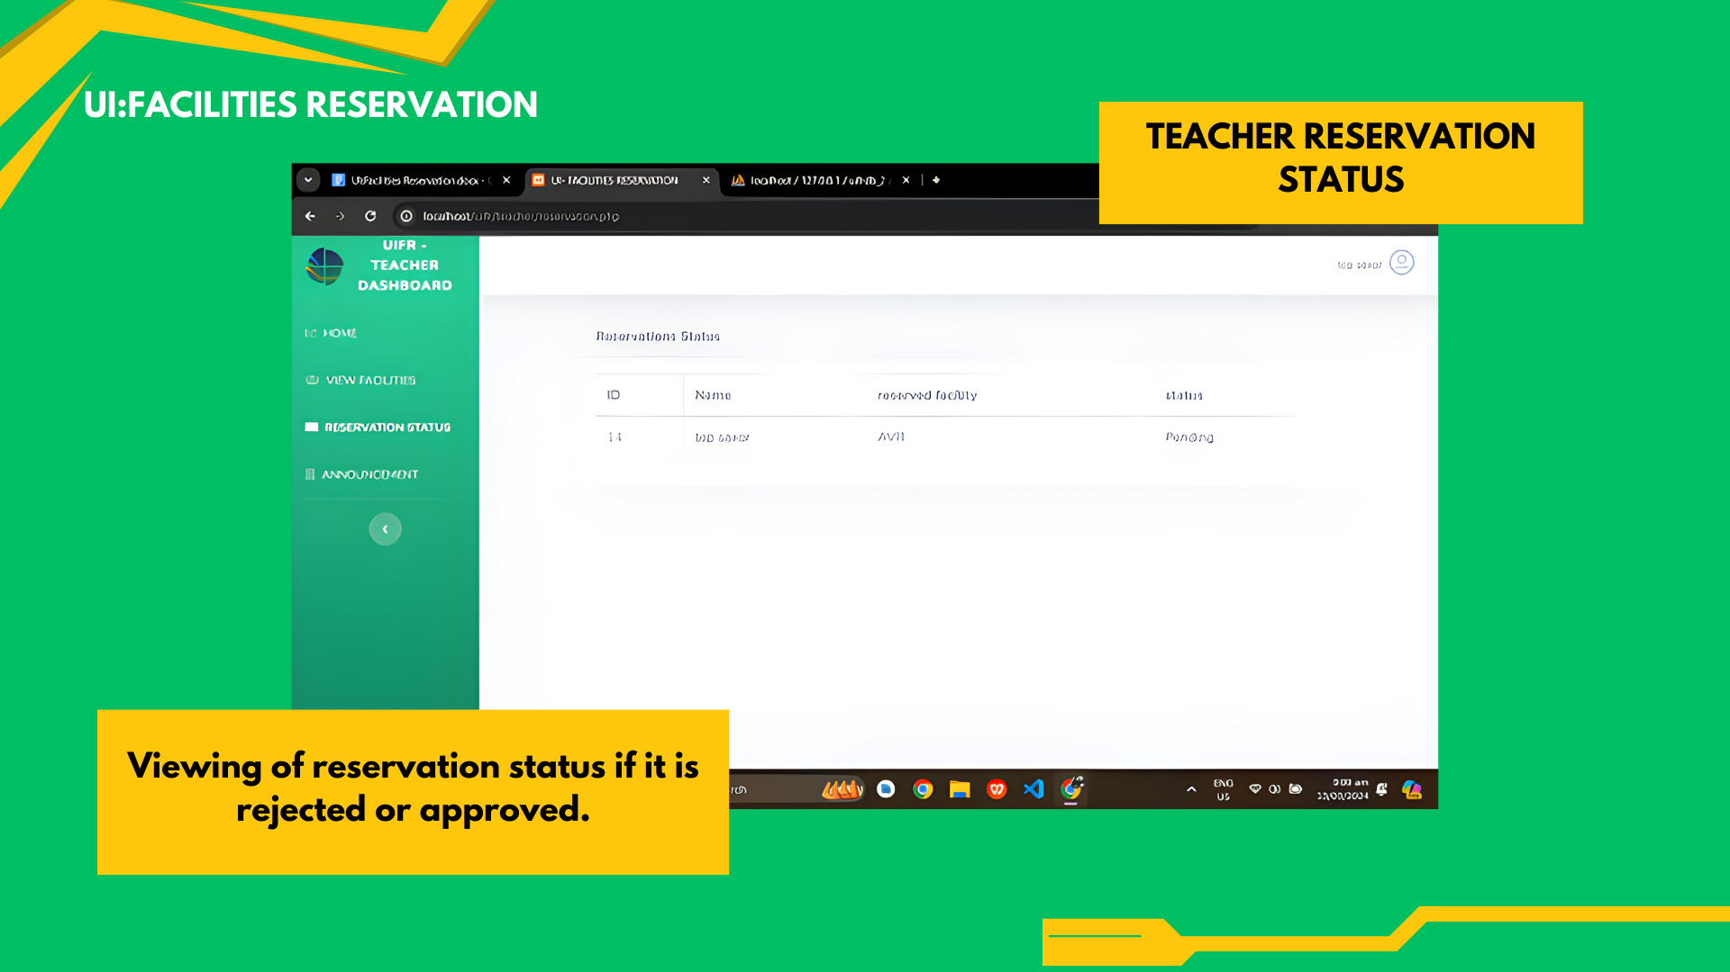

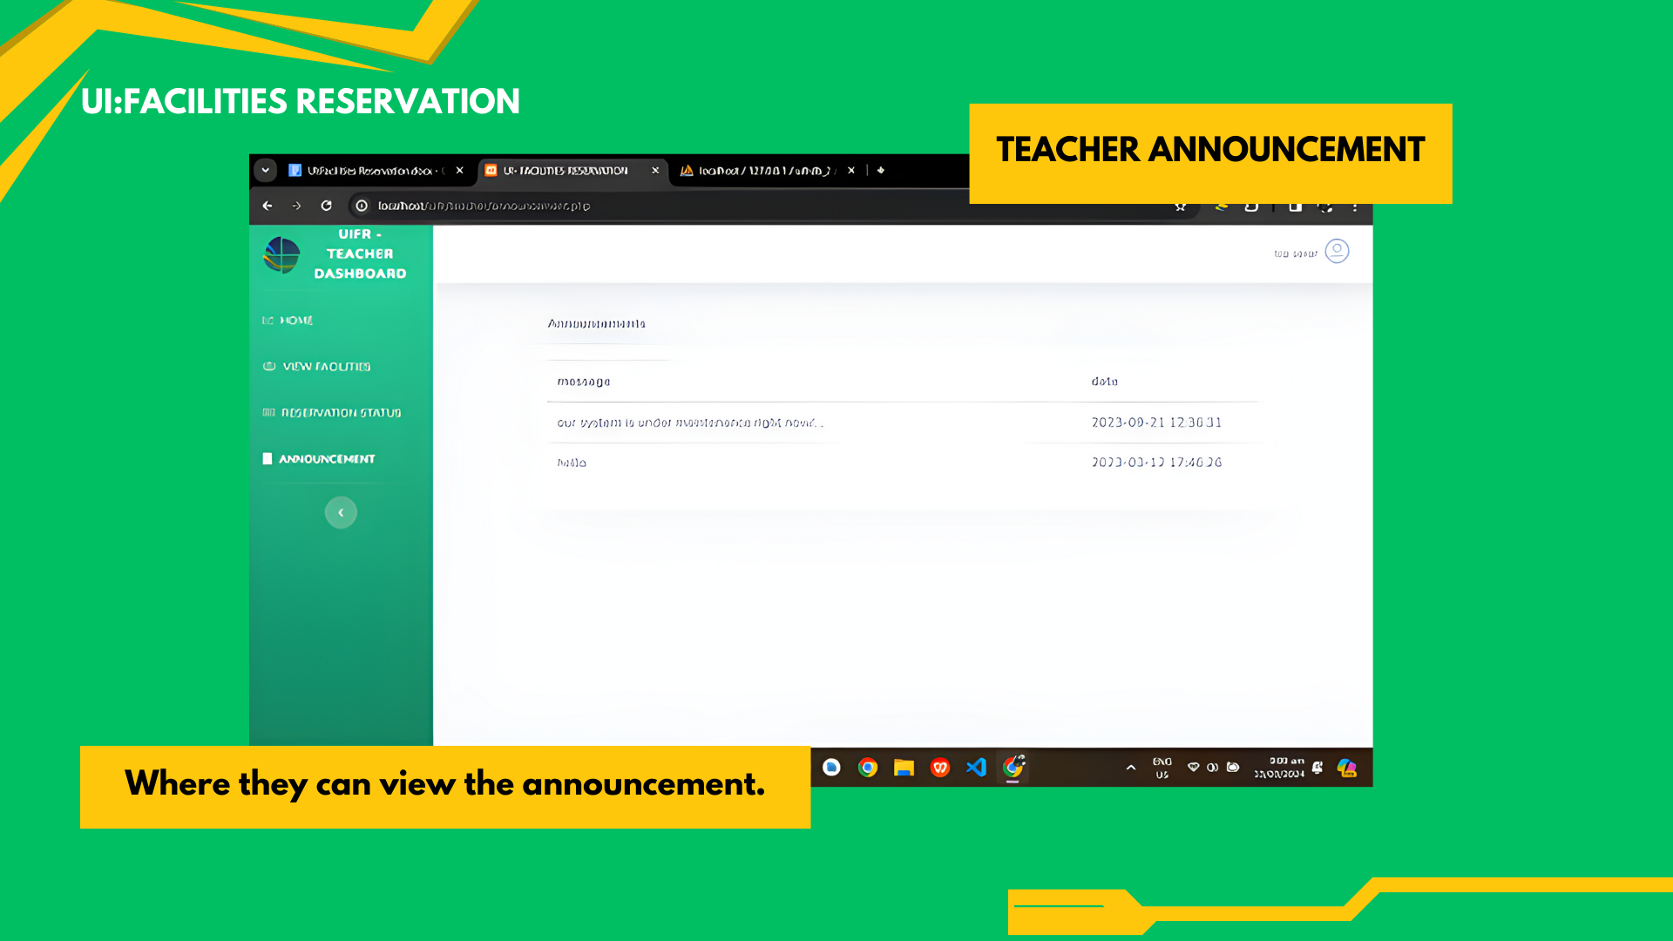

**COUNCIL USER GUIDE**

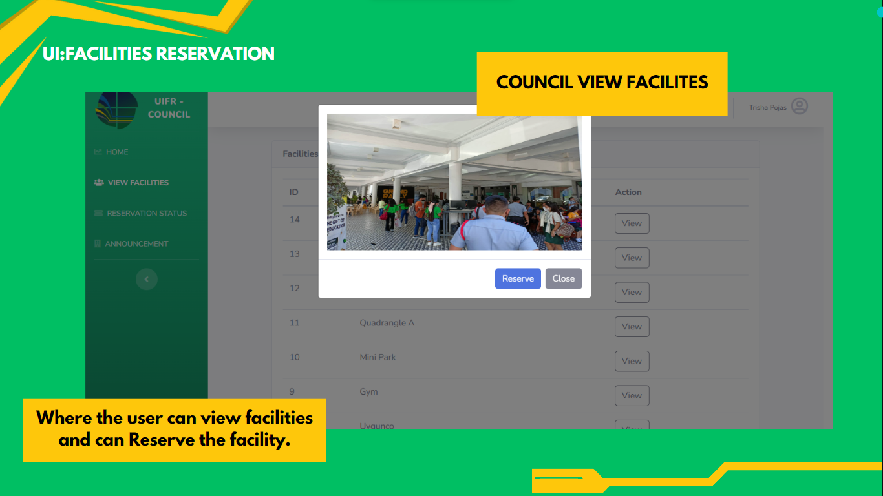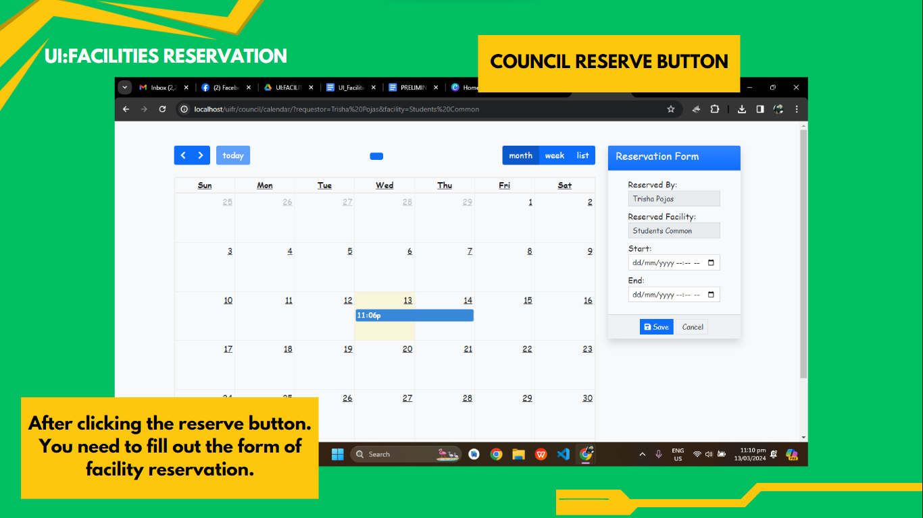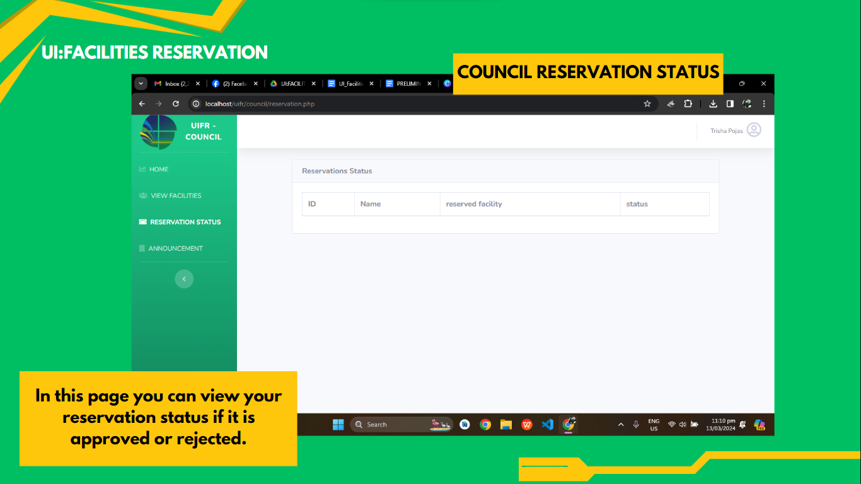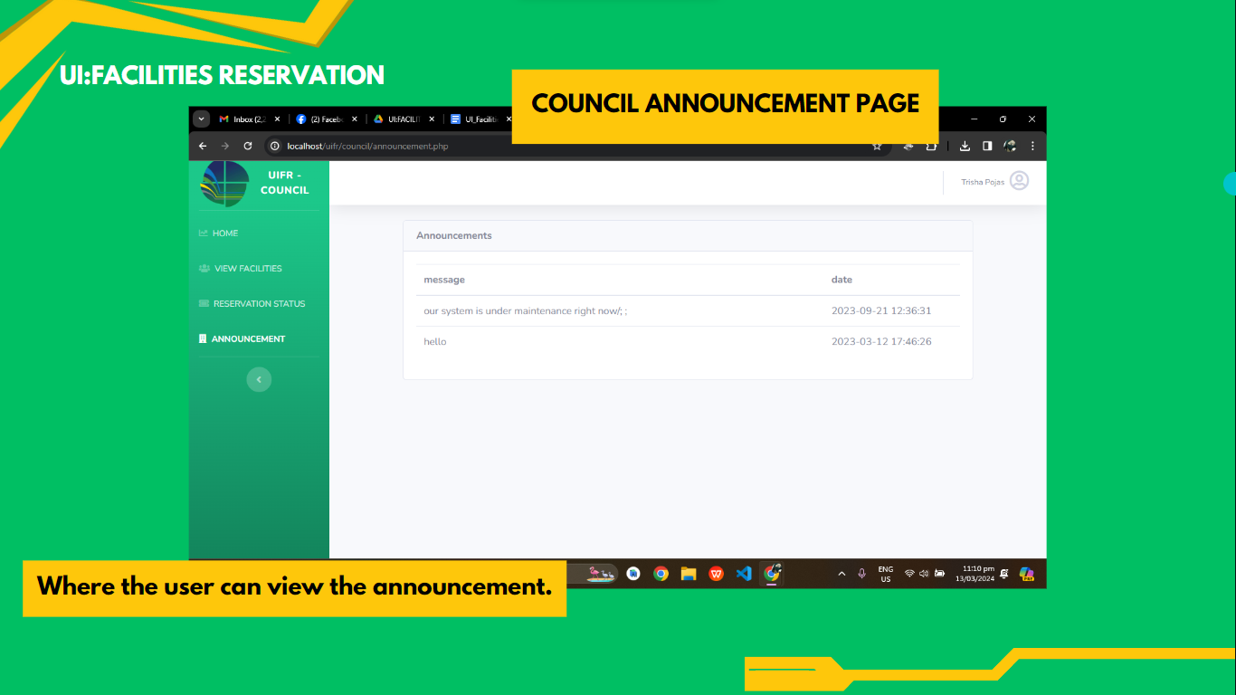

**CURRICULUM VITAE**

**PERSONAL BACKGROUND**

Name : Jason Lawrence G, Madregalejo

Date of Birth : June 15, 2000

Place of Birth : St Pauls Hospital Iloilo

Civil Status : Single

Home Address : Brgy Calaparan,Arevalo,Iloilo City

Parents : Analyn G, Madregalejo

**EDUCATIONAL BACKGROUND**

Elementary : Palay Elementary School

Secondary : Palay Integrated School

Senior High School : Palay Integrated School

Tertiary : PHINMA University Of Iloilo

**PERSONAL BACKGROUND**

Name : Guantero, Rick David L.

Date of Birth : 04,11,2000

Place of Birth : WVMC

Civil Status : Single

Home Address : Brgy. South San Jose Molo Iloilo City

Parents : Amy Lagudiña

**EDUCATIONAL BACKGROUND**

Elementary :Molo 1 Elementary School

Secondary :Iloilo City National High School

Senior High School : PHINMA University Of Iloilo

Tertiary : PHINMA University Of Iloilo

**PERSONAL BACKGROUND**

Name : Raphael Louis D. Alcazar

Date of Birth : 10/16/2000

Place of Birth : WVMC

Civil Status : Single

Home Address : Tanza Esperanza Iloilo City

Parents : Lory Alcazar & Robert Alcazar

**EDUCATIONAL BACKGROUND**

Elementary : Tabucan Elem. School

Secondary : MNHS

Senior High School : MNHS

Tertiary : PHINMA University of Iloilo

**PERSONAL BACKGROUND**

Name : Tiffany Kaile E. Roxas

Date of Birth : March 7, 2000

Place of Birth : Igbaras, Iloilo

Civil Status : Single

Home Address : Brgy. 4 Pob. Gines St. Igbaras, Iloilo

Parents : Robert P. Roxas | Ma. Elena E. Roxas

**EDUCATIONAL BACKGROUND**

Elementary : Igbaras Central Elem. School

Secondary : Igbaras National High School

Senior High School : Guimbal National High School

Tertiary : PHINMA University of Iloilo

**PERSONAL BACKGROUND**

Name : Trisha G. Pojas

Date of Birth : February 23,2002

Place of Birth : WVMC, Iloilo City

Civil Status : Single

Home Address : Project 3 Jica Sooc Arevalo Iloilo City

Parents : Elena Pojas | Wilfredo Pojas

**EDUCATIONAL BACKGROUND**

Elementary : MoloI Elementary School

Secondary : Ramon Avanceña National High School

Senior High School : Iloilo City National High School

Tertiary : PHINMA University of Iloilo

GRAMMARIAN